WATTSAVER

**UCS503 Software Engineering Project Report**

**Mid-Semester Evaluation**

**Submitted by:**

**Atin Arora – 102103548**

**Khushi Agarwal – 102103549**

**Samarjeet Singh – 102103652**

**BE THIRD YEAR**

**COE20 Group No:4**

**Submitted to:**

**Ms. Arwinder Dhillon**



**Computer Science and Engineering Department**

**TIET, Patiala**

**September 2023**

**TABLE OF CONTENTS**

S.No. Assignment Page No.

## **1 Project Selection Phase**

1.1 Software Bid 3

1.2 Project Writeup 6

## **2 Analysis Phase**

2.1 Use Cases

2.1.1 Use-Case Diagrams 8

2.1.2 Use Case Templates 9

2.2 Activity diagram and Swimlane Diagrams 11

2.3 Data Flow Diagrams (DFDs)

2.3.1 DFD Level 0 13

2.3.2 DFD Level 1 13

2.3.2 DFD Level 2 14

2.4 Software Requirement Specification in IEEE Format 15

2.5 User Story Cards 25

## **3 Design Phase**

3.1 Class Diagram 28

3.2 Sequence Diagram 29

3.3 Collaboration Diagram 30

3.4 State Chart Diagram 31

## **4 Implementation**

4.1 Component Diagram 32

4.2 Deployment Diagram 33

4.3 Screenshots 34

## **3 Testing**

3.1 Testing Plan 36

3.2 Test Cases 37

3.3 Test Reports 41

# 1. Project Selection Phase

1.1. Software Bid

Software Bid/ Project Teams

Group : 4 Dated: 20-Sept-2023

**Team Name: Wattsavers**

**Team ID :4**

|  |  |  |  |
| --- | --- | --- | --- |
| Name | Roll No | Project Experience | Programming Language used |
| Atin Arora | 102103548 | Video to Subtitle Generator using python and Deep Learning | Python |
| Khushi Agarwal | 102103549 | Indian Sign Language Detector And Translator | Python |
| Samarjeet Singh | 102103562 | Indian Sign Language Detector And Translator , Minecraft Clone | Python, React |

**Programming Language / Environment Experience**

List the languages you are most comfortable developing in, **as a team**, in your order of preference. Many of the projects involve Java or C/C++ programming.

1. Python

2. Javascript

3. C/C++

**Choices of Projects:**

Please select **4 projects** your team would like to work on, by order of preference: *[Write at-least one paragraph for each choice (motivation, reason for choice, feasibility analysis, etc.)]*

|  |  |
| --- | --- |
| First Choice | **WATTSAVER: Our project aims to revolutionize energy conservation by automating the process of detecting empty rooms with lights on. Through the utilization of CCTV cameras and advanced human detection technology, our system efficiently identifies unoccupied spaces. When an empty room with active lighting is detected, the system triggers immediate notifications to administrators, minimizing the need for manual checks by security personnel. This innovative solution extends its applicability to various workspaces, including hospitals, hotels, universities, and offices, offering a cost-effective and eco-friendly means to reduce electricity wastage and enhance operational efficiency. The automation of this process ensures a seamless and sustainable approach to energy conservation.** |
| Second Choice | **DOG-PEDIA:** Dogpedia operates by utilizing image recognition technology to scan dogs as a whole. When a user points their smartphone camera at a dog, the system identifies the unique features and characteristics of the dog and matches them with the data stored in the database. This allows users to instantly access information about the scanned dog, including its vaccination status, species, color, and emergency contact details.. It enhances campus safety by providing real-time information on the health and identification of dogs in the vicinity. |
| Third Choice | **ALUMNET(Alumni Network**): Guidance is what that streamlines your effort and getting that guidance from our alumni who are already in the field.Therefore, this website will become a portal for the alumni to tell about their milestone and all the steps they took to achieve success. This will also allow the students to directly ask any question to the alumni whose milestones inspire them. |
| Fourth Choice | **ErikShaw Campus**: This project envisions a convenient and eco-friendly transportation solution tailored to the unique needs of a university or corporate campus, much like the popular ride-sharing service, Ola. This innovative initiative aims to provide efficient on-demand electric rickshaw (erikshaw) services within the campus premises. Users can easily book a ride via a mobile app, eliminating the hassle of walking long distances or waiting for conventional shuttles. ErikShaw Campus not only promotes sustainable transportation but also enhances accessibility and mobility for students, faculty, and staff. |

**Additional Remarks/ Inputs**

Please tell us about any other factors that we should take into consideration (e.g., if you really would like to work on a project for some particularly convincing reason).

**Reasons –**

1. **Energy Conservation**: The project's primary goal is to have a significant impact on energy conservation. By reducing unnecessary electricity usage in various settings, it contributes to a sustainable future and helps combat climate change.
2. **Cost Reduction**: Implementing this project can result in substantial cost savings for institutions and organizations by lowering electricity bills, making it financially beneficial and promoting efficient resource allocation.
3. **Environmental Impact**: Energy conservation directly correlates with a reduced carbon footprint. This project has the potential to make a significant positive impact on the environment by curbing greenhouse gas emissions associated with energy production.
4. **Efficiency Improvement**: The automation of room occupancy detection and lighting control enhances operational efficiency in monitored spaces. It minimizes the need for manual interventions, saving time and resources.
5. **Scalability and Broad Applicability**: The versatility of this project extends its impact to a wide range of workspaces, including educational institutions, commercial buildings, and more. Its scalability allows for broader adoption and, consequently, a more extensive positive influence on energy conservation efforts.

1.2. Project Writeup

**Project Write-Up**

**Objective:**

The primary goal of this project is to develop a software system aimed at conserving electricity through the use of human detection technology. The system's core objective is to reduce unnecessary energy consumption by identifying the presence of individuals in classrooms using basic CCTV cameras. When the system detects an unoccupied classroom with the lights switched on, it will promptly notify the administrator through a live web notification.

**Functionality:**

1. Human Detection:

- The system utilizes CCTV cameras to monitor classrooms and detect human presence.

- It distinguishes between occupied and unoccupied classrooms based on this detection.

2. Notification System:

- In the event of an unoccupied classroom with lights on, the system triggers a live web notification to alert the administrator.

3. Real-time Monitoring:

- The system provides the administrator with real-time access to the status of all classrooms on the campus through a dedicated website.

**Applicability:**

**-** This system's utility extends beyond university campuses; it can also be employed in various educational institutions, as well as commercial and service sectors.

- The innovative product addresses a significant challenge faced by institutions: the wastage of electricity and the inefficient allocation of human labor.

- Traditional methods involve manual inspections that consume time and resources, requiring personnel to continuously check classrooms for occupancy and manually switch off lights.

- With this product, administrators can effortlessly access a list of classrooms where lights are on but no human presence is detected, simplifying the process and reducing the risk of electricity wastage due to oversight or inadequate checks.

The Gantt chart is as follows:

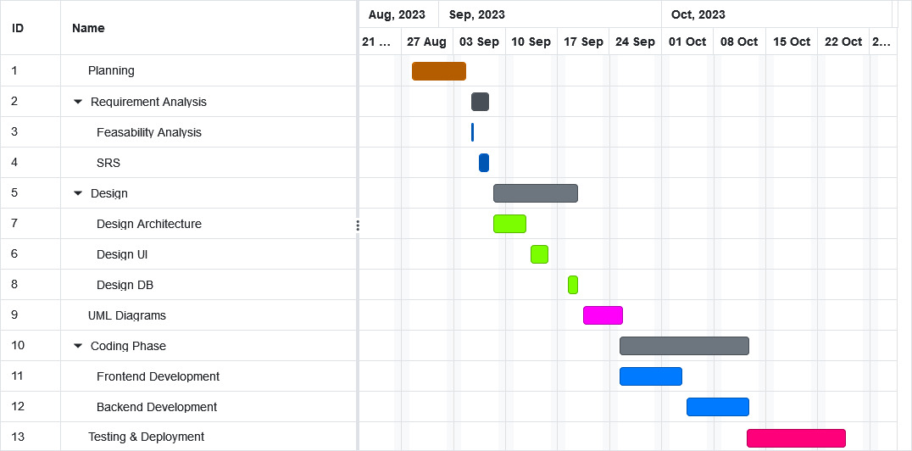

2. Analysis Phase

2.1. USE CASE

## 2.1.1. USE CASE DIAGRAM

The used case diagram is as follows:

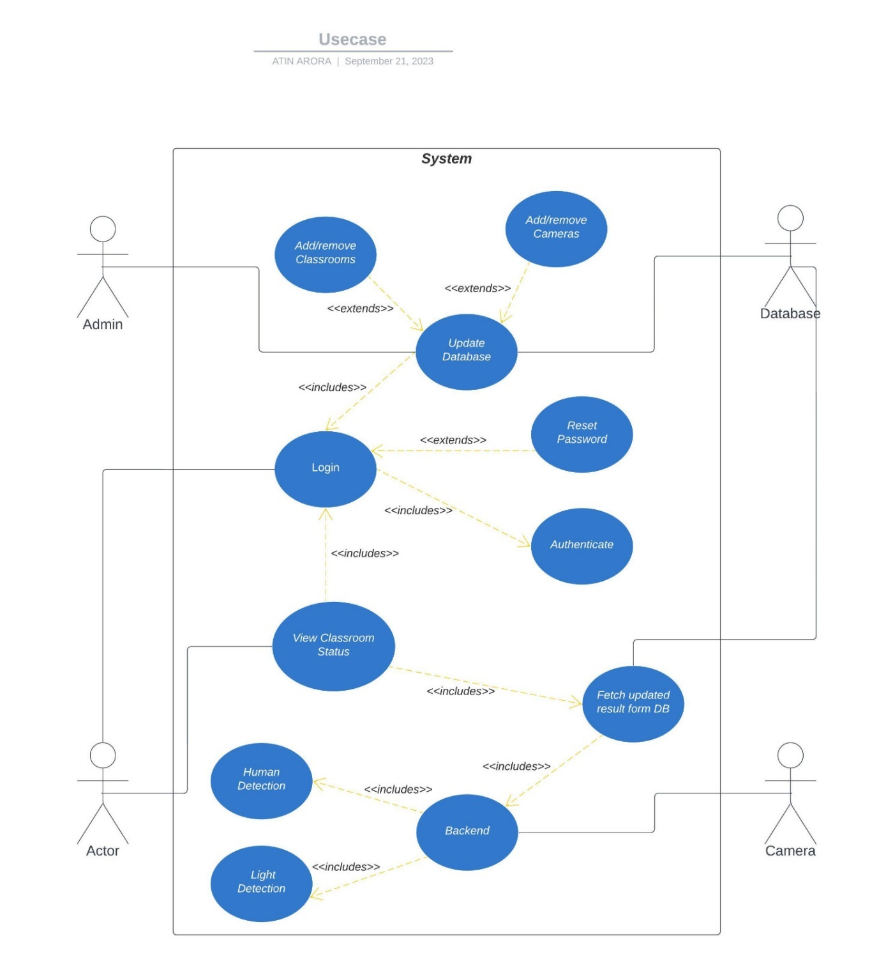

2.1.2 USE CASE TEMPLATES

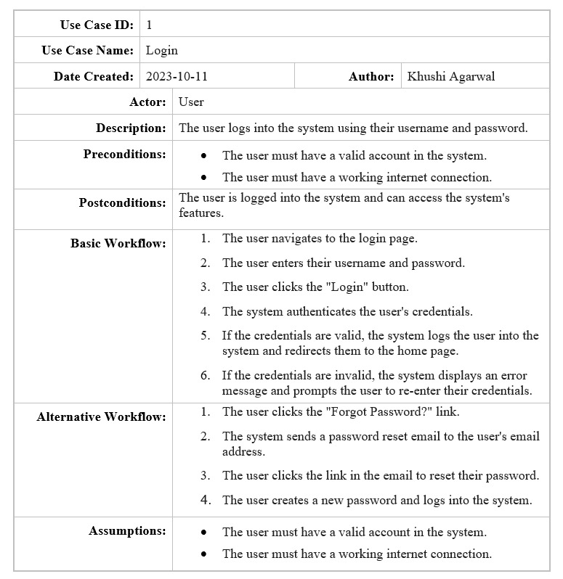

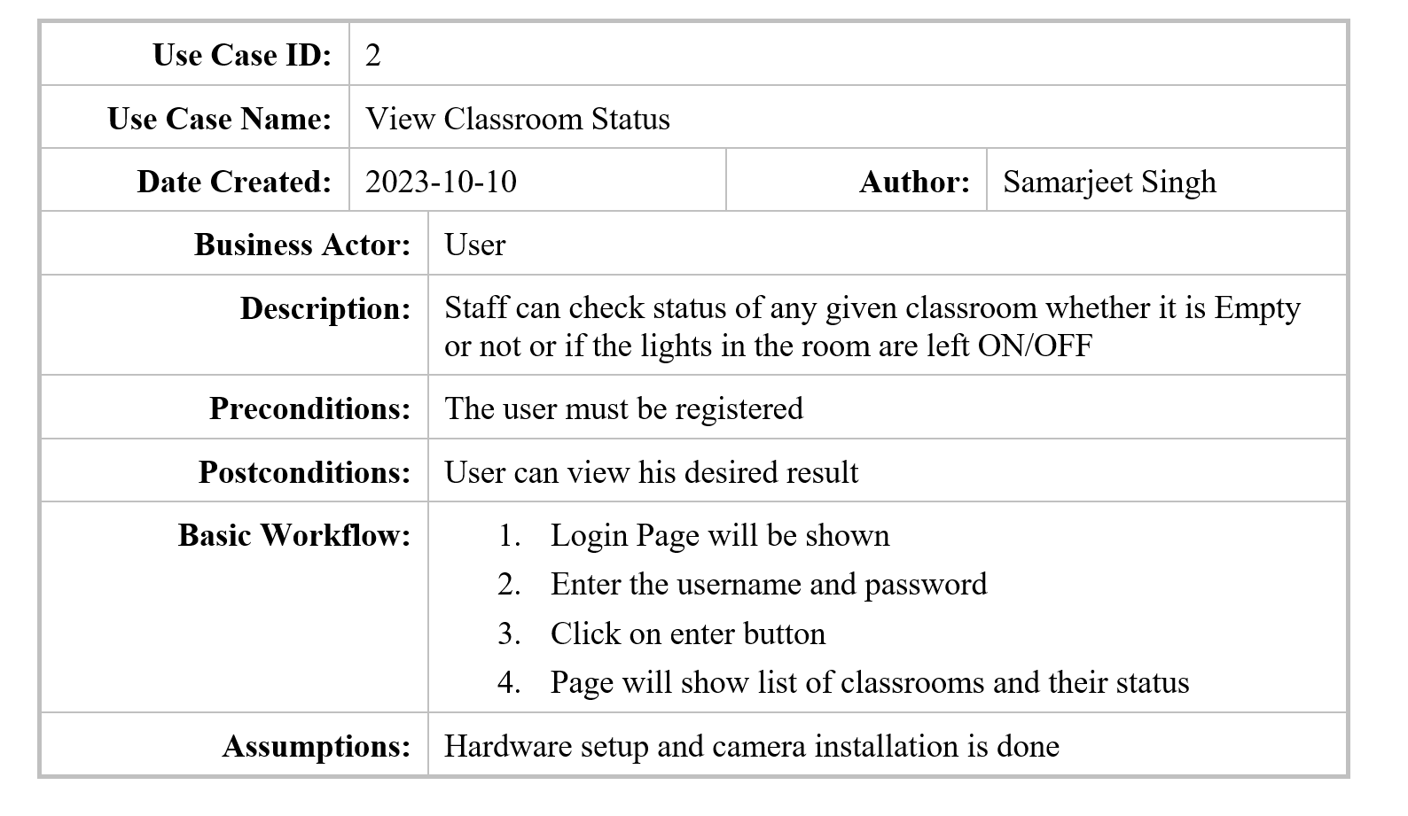

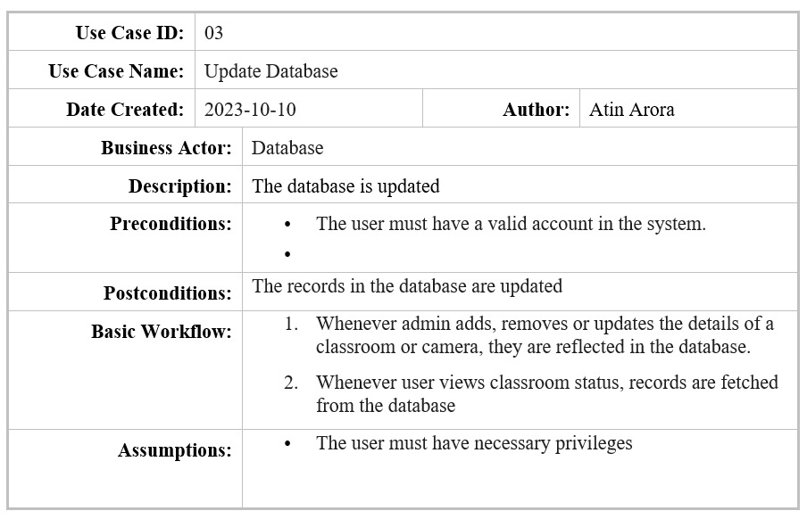

2.2 Activity diagram and Swimlane Diagrams

The Activity diagram is as follows:

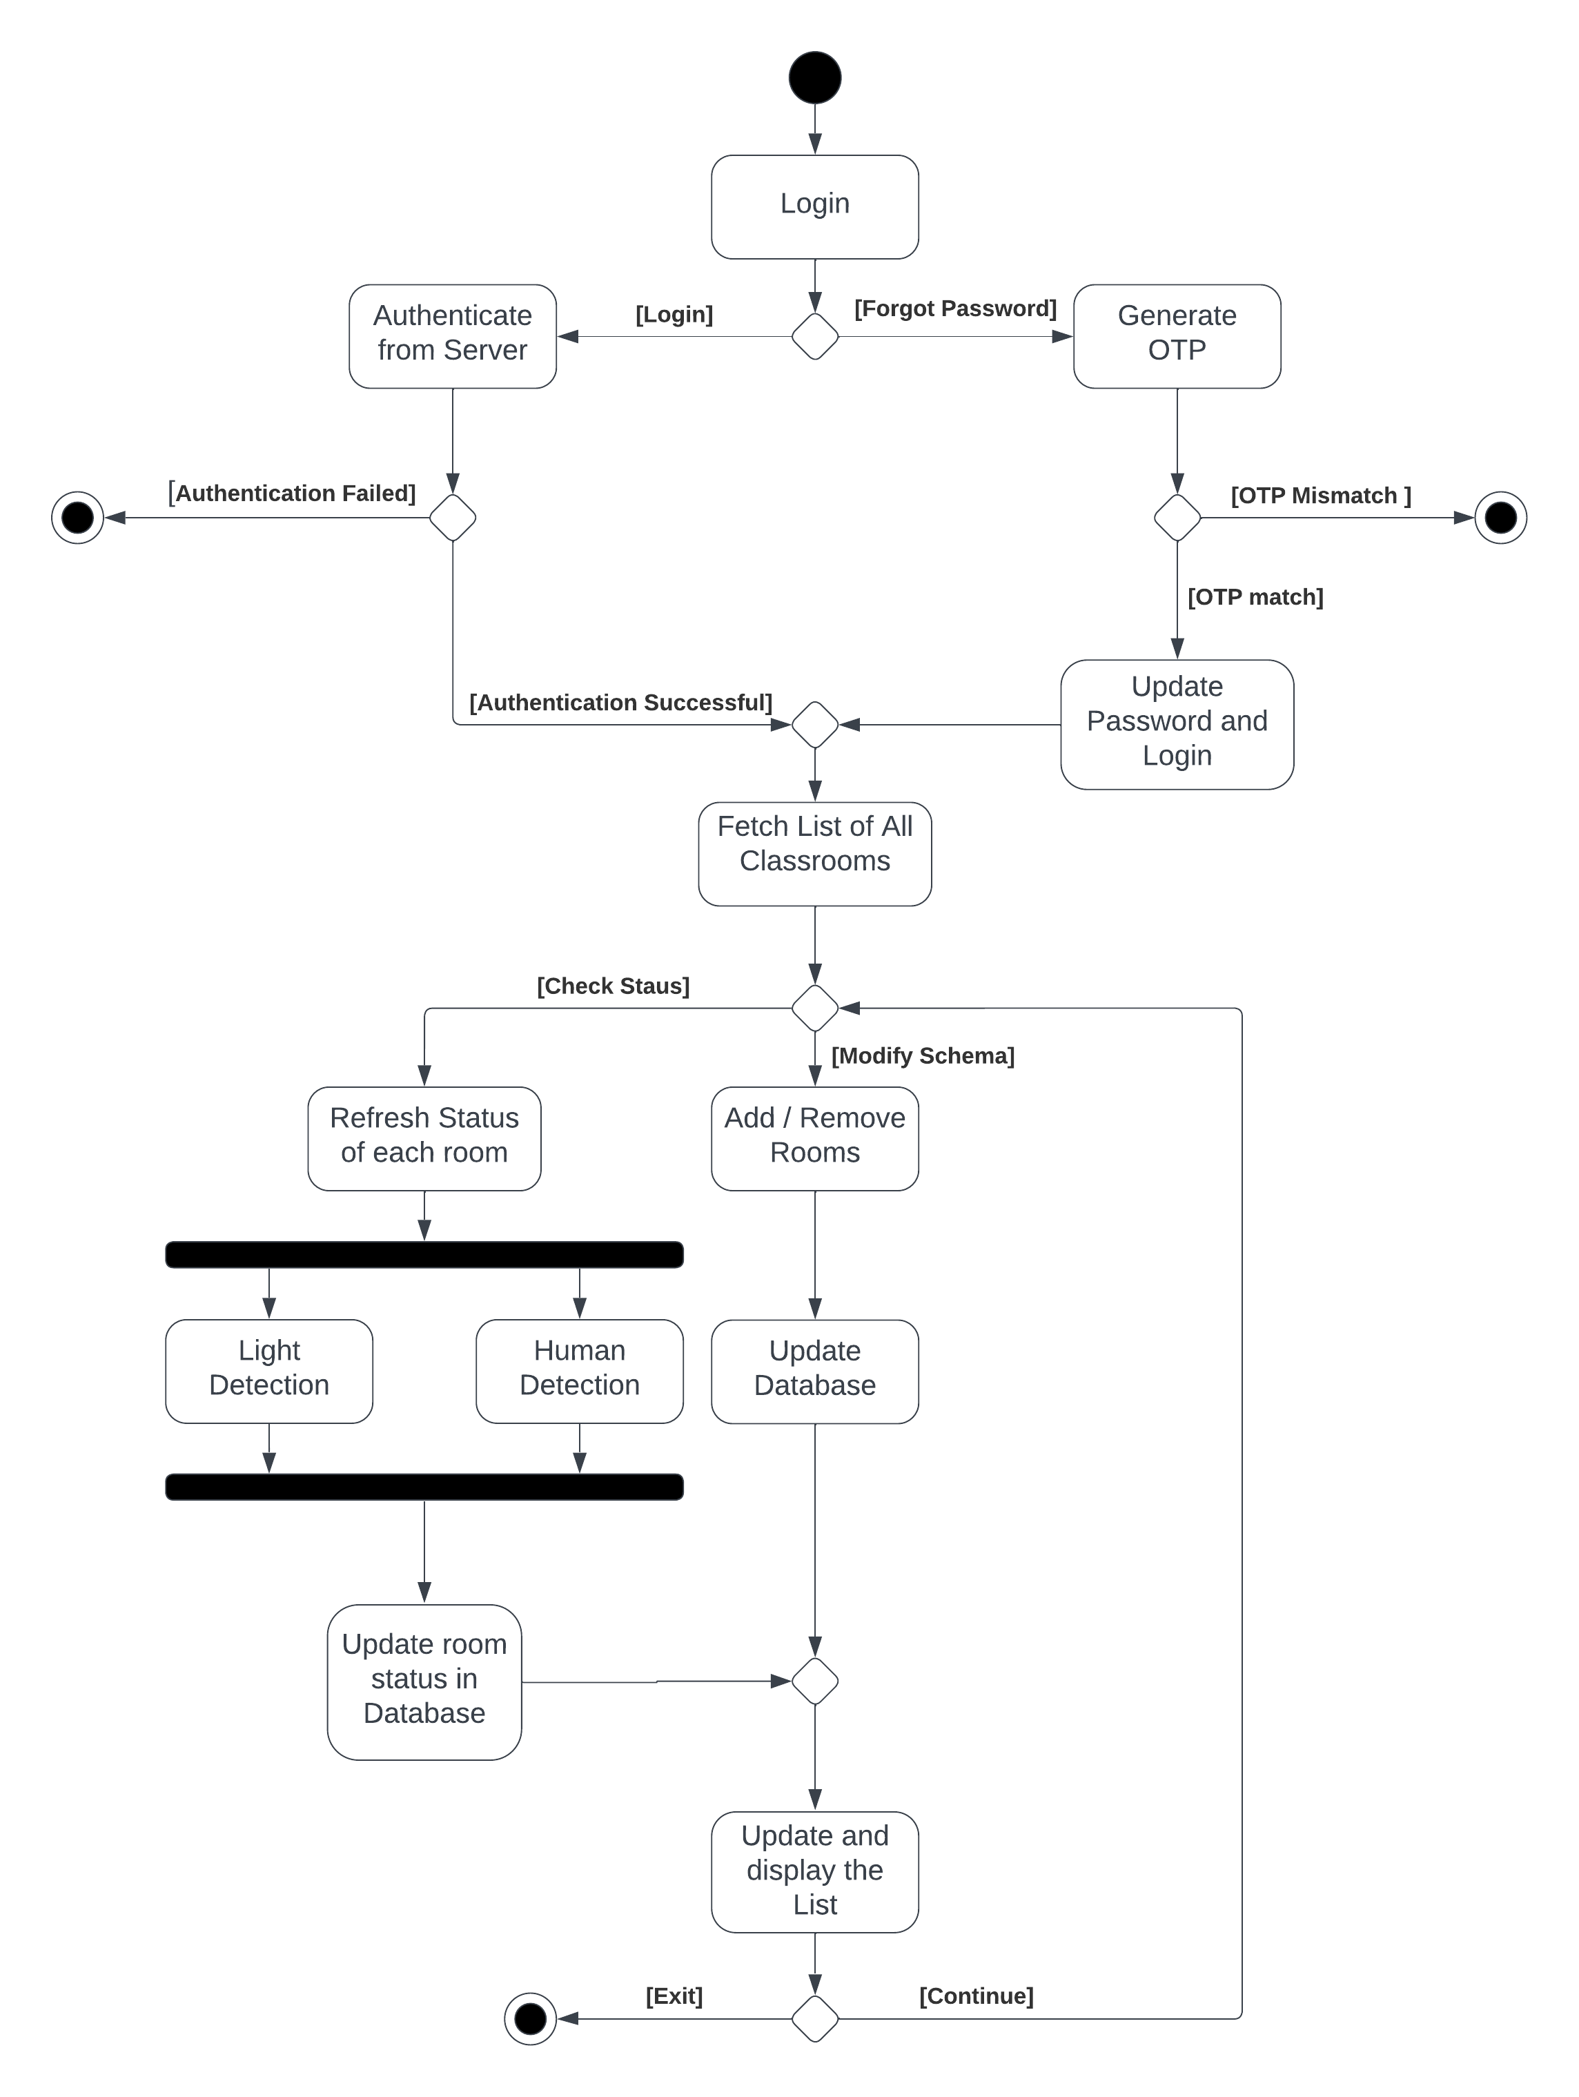

The Swimlane diagram is as follows

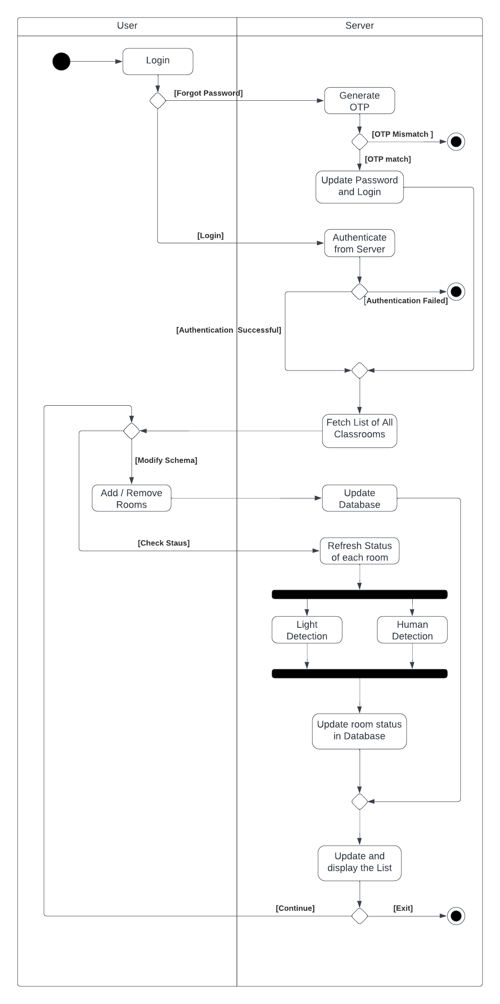

2.3 Data Flow Diagrams (DFDs)

2.3.1 DFD Level 0

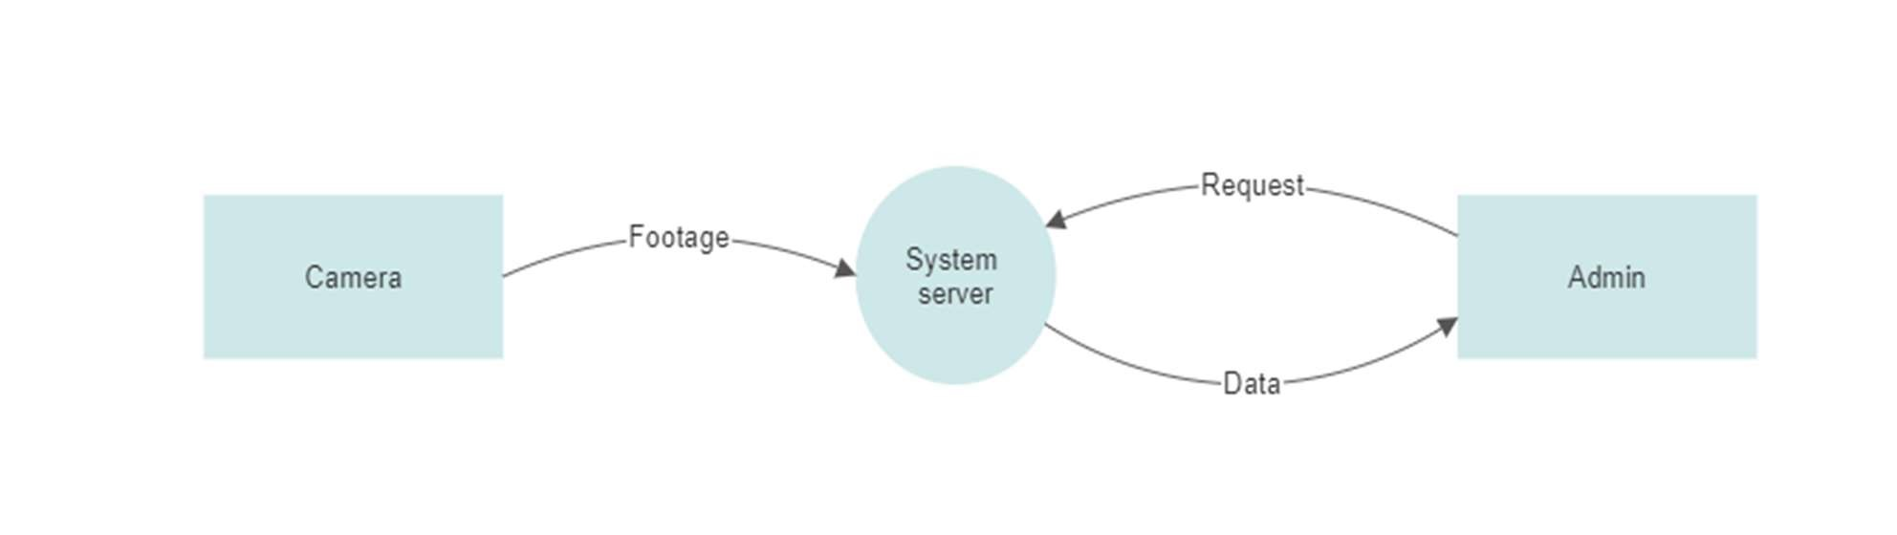

2.3.2 DFD Level 1

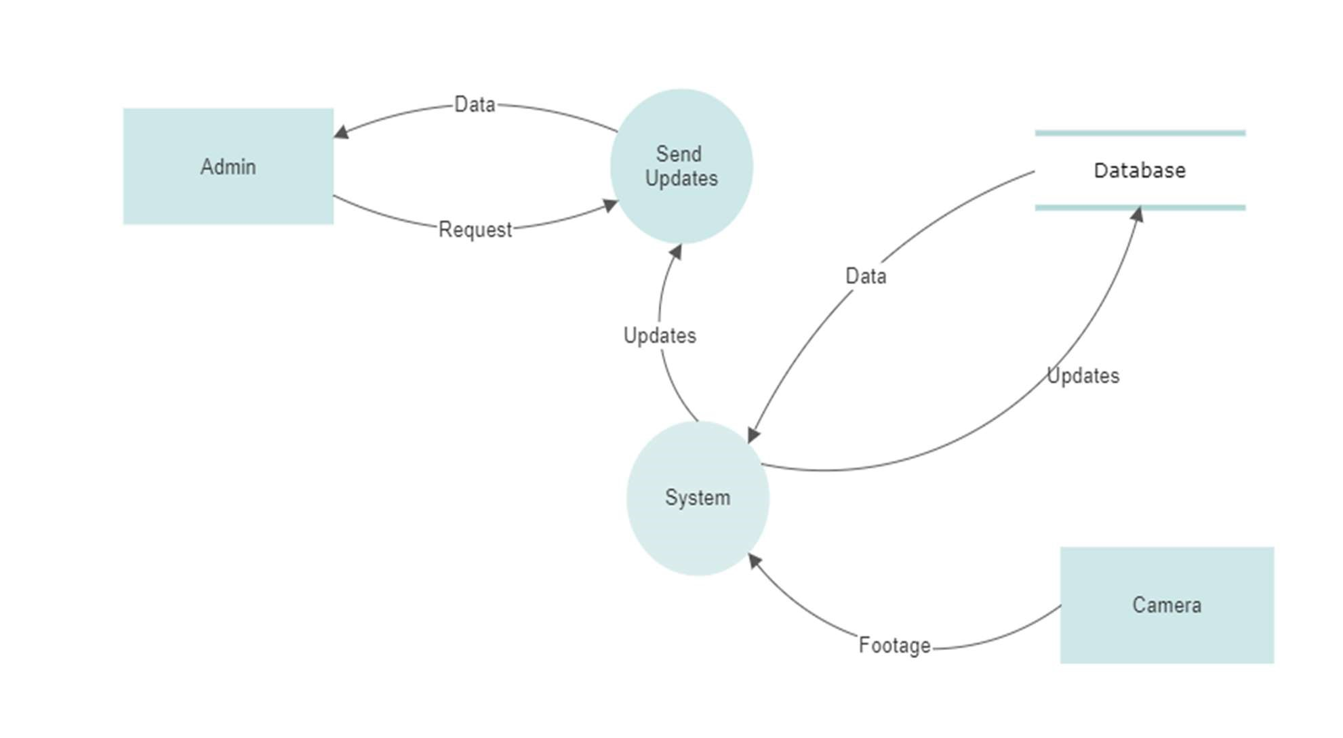

2.3.2 DFD Level 2

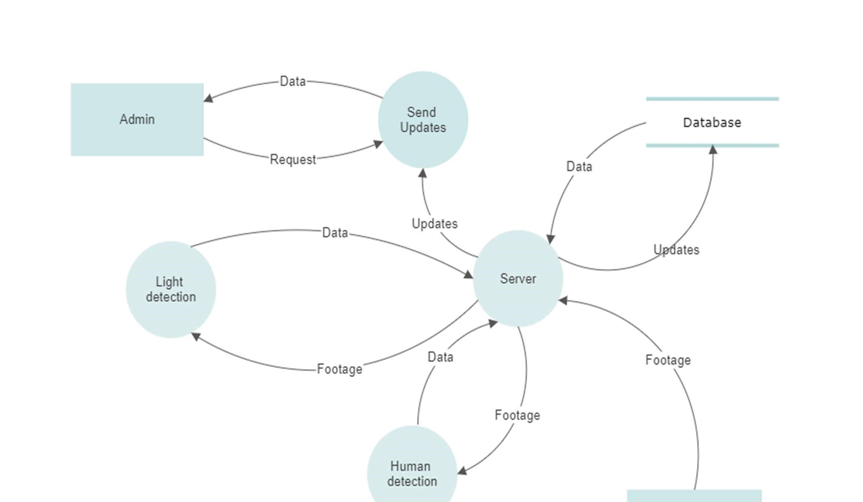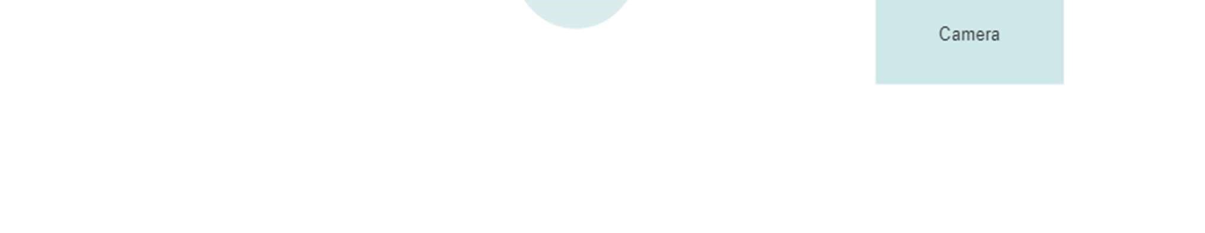

2.4 Software Requirement Specification in IEEE Format

**Software Requirements**

**Specification**

**for**

**WattSaver**

**Version 1.0 approved**

**Prepared by :**

**Atin Arora - 102103548**

**Khushi Agarwal -102103549**

**Samarjeet Singh - 102103562**

**Team - 4**

**20/09/2023**

**Table of Contents**

**Table of Contents ii**

**Revision History ii**

1. **Introduction 1**
   1. Purpose 1
   2. Intended Audience and Reading Suggestions 1
   3. Product Scope 1
   4. References 1
2. **Overall Description 2**
   1. Product Perspective 2
   2. Product Functions 2
   3. User Classes and Characteristics 4
   4. Operating Environment 5
   5. Design and Implementation Constraints 5
   6. Assumptions and Dependencies 5
3. **External Interface Requirements 6**
   1. User Interfaces 6
   2. Hardware Interfaces 6
   3. Software Interfaces 6
   4. Communications Interfaces 6
4. **System Features 7**
   1. Human detection: 7
   2. Light Detection: 7
   3. Check Lab/Classroom Status: 7
   4. Send Live Update : 8
5. **Other Nonfunctional Requirements` 8**
   1. Performance Requirements 8
   2. Safety Requirements 8
   3. Security Requirements 8
6. **Other Requirements 8**

**Appendix A: Glossary 5**

**Revision History**

|  |  |  |  |
| --- | --- | --- | --- |
| **Name** | **Date** | **Reason For Changes** | **Version** |
|  |  |  |  |
|  |  |  |  |

1. **Introduction**
   1. **Purpose**

The primary purpose of this Software Requirements Specification (SRS) document is to provide a comprehensive overview of our software product, encompassing its whole set of features and objectives. This paper provides an overview of the user interface, hardware, and software requirements of the project, as well as the target population it is designed for. This statement elucidates the perspectives of our customer, team, and audience on the product and its functionalities.

* 1. **Intended Audience and Reading Suggestions**

This SRS document is intended for the following audience groups:

1. **Developers:** To understand project requirements and design specifications.
2. **Project Managers:** To ensure project alignment with requirements and goals.
3. **Testing Team:** To create test cases and validate requirements.
4. **Instructors and Graders:** To evaluate adherence to software engineering principles.
   1. **Product Scope**

The goal is to design a software intending to conserve electricity based on human detection, including Access Control. This system will use a simple CCTV camera to detect human presence in classrooms. In case the classroom is detected empty and the lights are on, the system will notify the administrator regarding the same via a live web notification using web sockets. Furthermore, this system will allow the administrator to have access to the status of all classrooms in the campus through a website. [ data storage and backend info] This system will make administration easier and prevent unnecessary electricity wastage.

The software must perform the following operations:

1. Human detection in classrooms

2. Light detection if the classroom is empty

3. Send live status notification – On detecting light and human presence, the software

must be able to notify the administrator regarding the status of different classrooms.

* 1. **References**

YOLOv3 Documentation - https://pjreddie.com/darknet/yolo/

1. **Overall Description**
   1. **Product Perspective**

This product is a new, self-contained product. It serves as a remedy for two significant problems the institutions are now facing: excessive labor consumption and power waste. It takes a lot of physical labor, wasting time and resources, to turn out the lights and constantly check for empty classes. Using this product, the administrator may see a list of classes where the classroom with the light on and no one in it is indicated. Therefore, the necessary staff could go to the highlighted classes and turn down the lights there rather than going through every classroom looking for the same thing. This lessens the possibility of electrical waste brought on by carelessness or inadequate inspection.

* 1. **Product Functions**

The product should be able to perform the following operations:

• The server should be able to access the data feed from classroom cameras.

• The server should be able to detect human presence in classrooms.

• The server should be able to detect light presence in classrooms.

• The sever should be able to update the classroom status in database.

• The server should be able to check the status and highlight the required classrooms in user

interface accordingly.

• The software product should be accessible to admin after successful log-in.

• The admin should be able to view the classroom status and check the highlighted

classrooms.

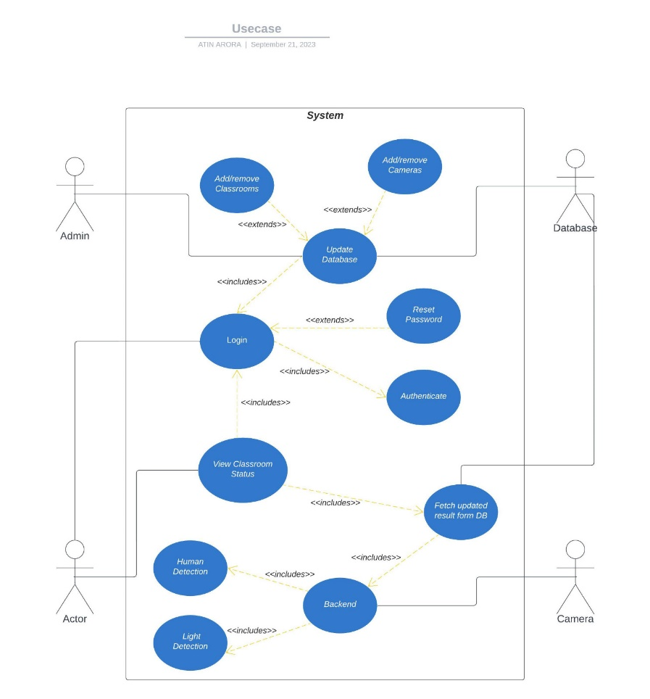The used case diagram is as follows:

The class diagram is as follows:

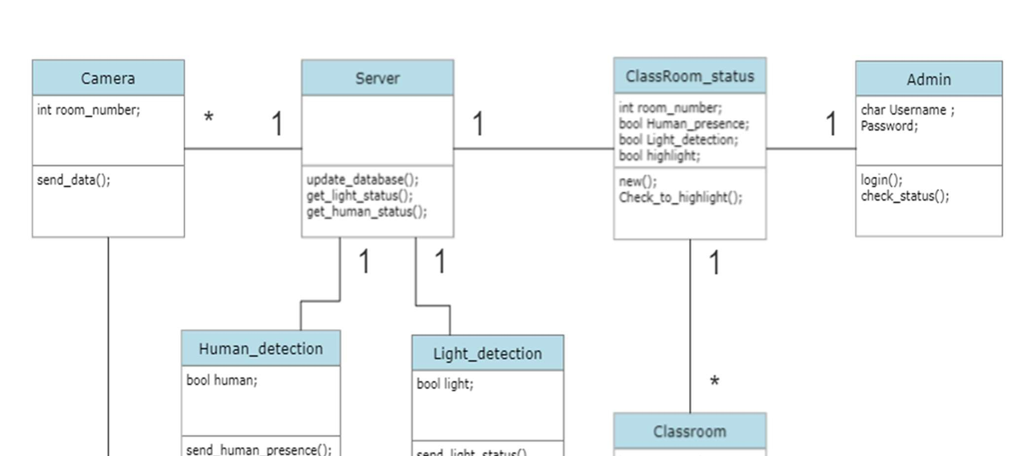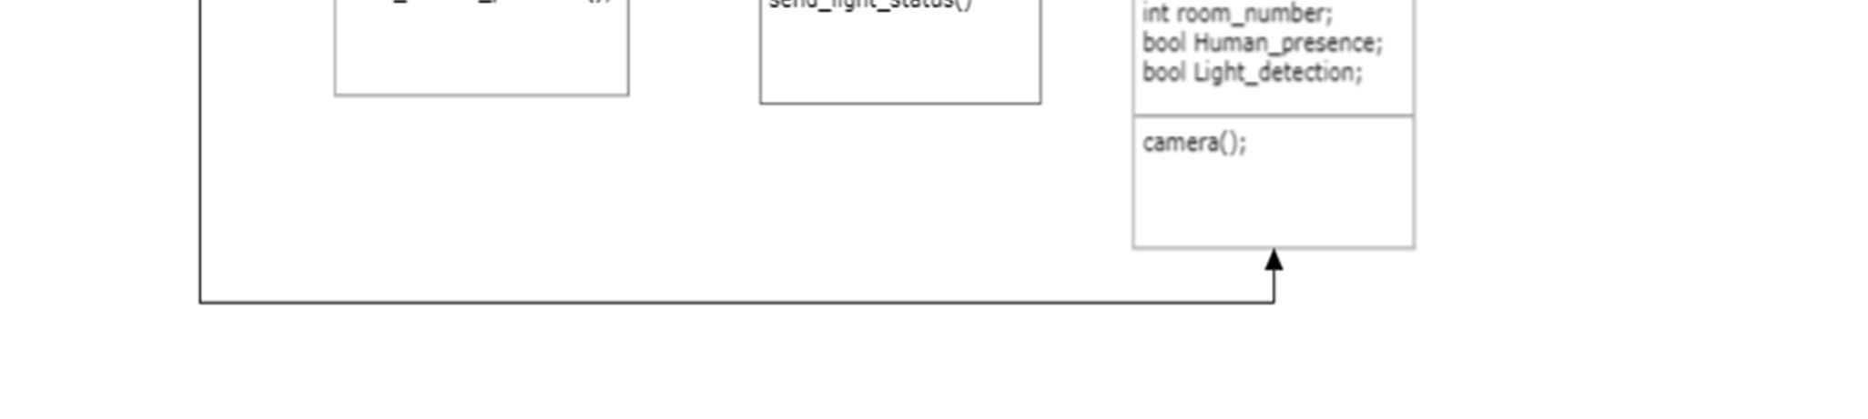

* 1. **User Classes and Characteristics**

The product will be used by the following user types with varying frequencies for the same:

1. Staff

2. Admin

The order of users is given in the decreasing order of frequency of the same. The User

Interface and features for each type of user will be different depending on the allowance and

permissions to access data.

1. The Staff monitors the classroom status using this software product. It can view the list

of classrooms in user interface. It can check the highlighted classrooms, i.e, the

classrooms which have no human presence but are having the lights in use leading to

electricity wastage.

2. The Admin can access the servers and can control the backend.

As one can see from the list, each user will have different educational background and

expertise level in using the system. Our goal is to develop software that should be easy to use

for all types of users

Thus, while designing the software one can assume that each user type has the following

characteristics:

The user is computer-literate and has little or no difficulty in using the software product to access

information such as room status.

* 1. **Operating Environment**

The software is deployable and operable on a server with a camera connection. The server must have a CPU and GPU that conform to the YOLOv3 system requirements.

* 1. **Design and Implementation Constraints**

The design and implementation constraints for the developers are the following:-

* The developer should have an appropriate system to handle the computing of YOLOv3
* The developers must have sufficient knowledge of python , CSS, HTML and JavaScript
  1. **Assumptions and Dependencies**

The following list presents the constraints, assumptions, dependencies or guidelines that are

imposed upon implementation of the system:

* System should meet the YOLOv3 hardware requirements.
* There must be a camera having an uninterrupted access to the room whose status has to be checked.
* A general knowledge of basic computer skills and basic working of web browsers are needed to avail the benefits of this system;
* A good network connection is required for the proper working of the system.

1. **External Interface Requirements**
   1. **User Interfaces**
   2. **Hardware Interfaces**

The following list represents the hardware interface requirements:

* **Camera** : The camera must be of 12 MP or higher and the camera must be connected to the server at all times. The camera will be providing live feed to the server using TCP/UDP/HTTP protocols.
* **Server** : The server must contain appropriate CPU and GPU to support YOLOv3 and it must contain a network adapter compatible to be linked with the cameras. The server should feed the data received from the camera to the program.
* **Screen** : To access the website, the user will need a computer screen of appropriate size.
  1. **Software Interfaces**

The following list represents the software interfaces:

* This software uses the YOLOv3 algorithm for human detection. YOLOv3 (You Only Look Once, Version 3) is a real-time object detection algorithm that identifies specific objects in videos, live feeds, or images. The YOLO machine learning algorithm uses features learned by a deep convolutional neural network to detect an object. The model comes pre-trained; the model does not need to be trained manually.
* The software uses OpenCV (Open Source Computer Vision Library) for computer vision and image processing. OpenCV (Open Source Computer Vision Library) is an open-source computer vision and machine learning software library. OpenCV was built to provide a common infrastructure for computer vision applications and to accelerate the use of machine perception in commercial products.
  1. **Communications Interfaces**

The communication interfaces for the system are as follows:

* The camera and server will establish communication using TCP (Transmission Control Protocol), UDP (User Datagram Protocol), and FTP (File Transfer Protocol) protocols.
* The web-client and server will communicate via HTTP (Hyper-Text Transfer Protocol)

1. **System Features**

The software aims to promote energy conservation through human detection. To achieve this objective, the software must encompass the following system features:

* Human Detection
* Light Detection
* Lab/Classroom Status Checking
* Access Log
* Live Notification Dispatch
  1. **Human Detection**

The software should be able to detect the presence of a human in a Classroom/lab to check whether a classroom is empty and Change the status in the Database.

Priority:-

* It is a High priority feature. It must be present for the system to run.

Stimulus:-

* No stimulus needed

Response Sequences:-

* The software will check for human presence using Live Feed from the CCTV

Camera installed in Classroom/Lab.

* Update the Database
  1. **Light Detection**

The software should be able to detect if lights are ON/OFF in a classroom and change the status in the database.

Priority:-

* It is a High priority feature it must be present for the system to run.

Stimulus:-

* No stimulus needed

Response Sequences:

* The software will check Whether lights are ON/OFF in the Room using a Live

Feed from the CCTV Camera installed in Classroom/Lab.

* Update the Database
  1. **Check Lab/Classroom Status**

The software should be able to tell if a Classroom is Empty or Full by using Human and Light Detection. Show the list of the classroom's status on the Admin portal.

Priority:-

* It is a High priority feature. It must be present for the system to serve its purpose.

Stimulus:-

* The software detected no human in a Classroom/Lab.

Response Sequences:-

* Checking the Database
* Update the Status list of the classrooms/labs.
  1. **Send Live Update**

The software should be able to send Live update to the Admins Whenever a classroom status changes to Empty, but Lights are Detected ON.

Priority:-

* It is a Medium priority feature. It is an additional feature.

Stimulus:-

* If no Human is detected, the lights are detected ON.

Response Sequences:-

* Send a Live Update to the Admin by highlighting the classroom Name

1. **Other Nonfunctional Requirements**
   1. **Performance Requirements**

The system must be able to click clear pictures of the given room repeatedly in specific time intervals and transit them to the server successfully. The server must be able to detect light and human presence with accuracy and precision quickly and henceforth update the classroom status. The camera must be a (camera must be of 12 MP or higher). There must be a good Network connection with Camera (approx. 10MB/sec link speed)

* 1. **Safety Requirements**

As such the system is a secure gateway and there should not be any loss, damage or harm that could result from the use of the product. However, if in use then there must be a notice that signifies people that there images are being captured.

* 1. **Security Requirements**

The camera must be placed in such a way that there is no chance of it getting damaged due to the activities that happen in its surroundings. The admin must change his/her password in every two weeks to avoid any illegal entry from entities such as hackers from the outside world. Moreover he/ she must not use the system from any more than two devices. The password should be very strong and should not be shared with anyone. Furthermore, the data gathered from the server should not be trackable (HTTPS)

**Appendix A: Glossary**

* + - **Access Control: -** Access control is a security technique that regulates who or what can view or use resources in a computing environment. It is a fundamental concept in security that minimizes risk to the business or organization.
    - **CITM: -** It stands for Certified Information Technology Manager. The CITM will review such key areas as corporate frameworks, software, databases, information systems, communications and management of personnel in relation to technology and from the point of view of the business manager.
    - **CNN:** - It stands for Convolutional Neural Network. It is a class of neural networks that specializes in processing data that has a grid-like topology, such as an image.
    - **CPU: -** It stands for Central Processing Unit. It is the component of a computer system that controls the interpretation and execution of instructions. The CPU of a PC consists of a single microprocessor, while the CPU of a more powerful mainframe consists of multiple processing devices, and in some cases, hundreds of them.
    - **FTP:** - It stands for File Transfer Protocol. It is a standard communication protocol used for the transfer of computer files from a server to a client on a computer network.
    - **GPU: -** Its stands for Graphics Processing Unit. It is a specialized electronic circuit designed to manipulate and alter memory to accelerate the creation of images in a frame buffer intended for output to a display device.
    - **HTTPS: -** Its stands for Hypertext Transfer Protocol Secure. It is a combination of the Hypertext Transfer Protocol (HTTP) with the Secure Socket Layer (SSL)/Transport Layer Security (TLS) protocol. TLS is an authentication and security protocol widely implemented in browsers and Web servers.
    - **OpenCV: -** It stands for Open Source Computer Vision. It is an open-source computer vision and machine learning software library. OpenCV was built to provide a common infrastructure for computer vision applications and to accelerate the use of machine perception in the commercial products.
    - **Pilot Phase:** - The pilot project is an initial small-scale implementation that is used to prove the viability of a project idea. This could involve either the exploration of a novel new approach or idea or the application of a standard approach recommended by outside parties but which is new to the organization.
    - **Stimulus:** - A stimulus is something that incites to action or exertion or quickens action.
    - **TCP:** - It stands for Transmission Control Protocol. It is one of the main protocols of the Internet protocol suite. It lies between the Application and Network Layers which are used in providing reliable delivery services. It is a connection-oriented protocol for communications that helps in the exchange of messages between the different devices over a network.
    - **UDP:** - It stands for User Datagram Protocol. It operates on top of the Internet Protocol (IP) to transmit datagrams over a network. UDP does not require the source and destination to establish a three-way handshake before transmission takes place. Additionally, there is no need for an end-to-end connection.
    - **YOLOv3:** - It stands for You Only Look Once version 3. It is a real-time object detection algorithm that identifies specific objects in videos, live feeds, or images. The YOLO machine learning algorithm uses features learned by a deep convolutional neural network to detect an object.

2.5 User story and User cards

Front side

Back side

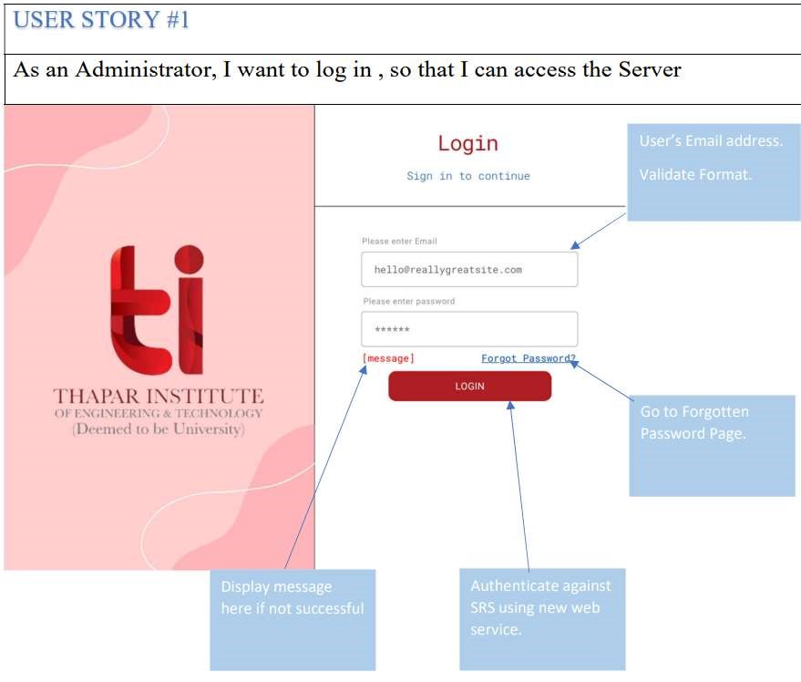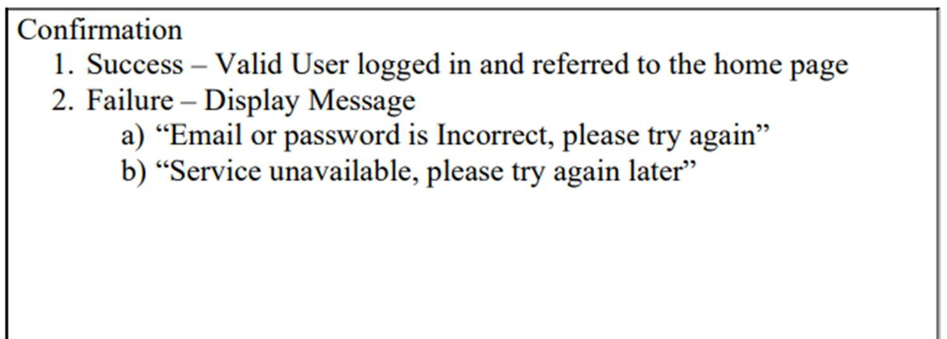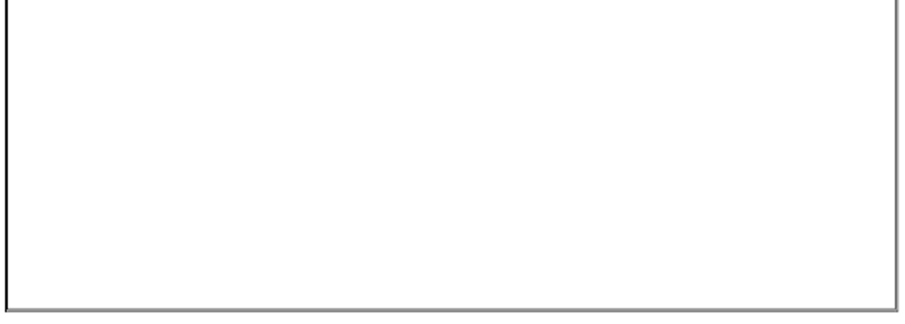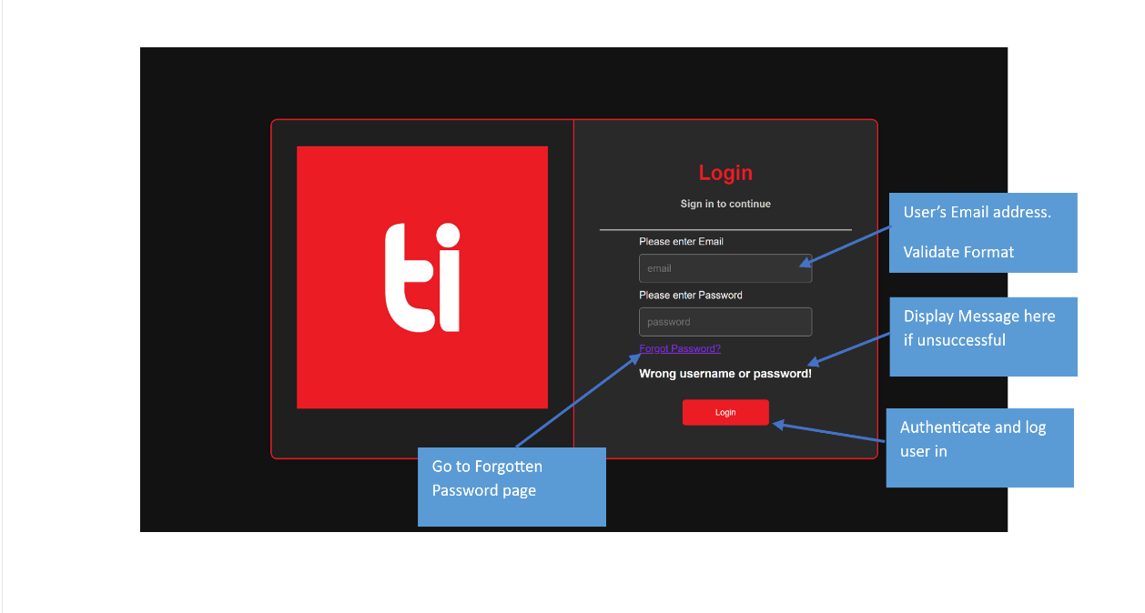

Front side

Back side

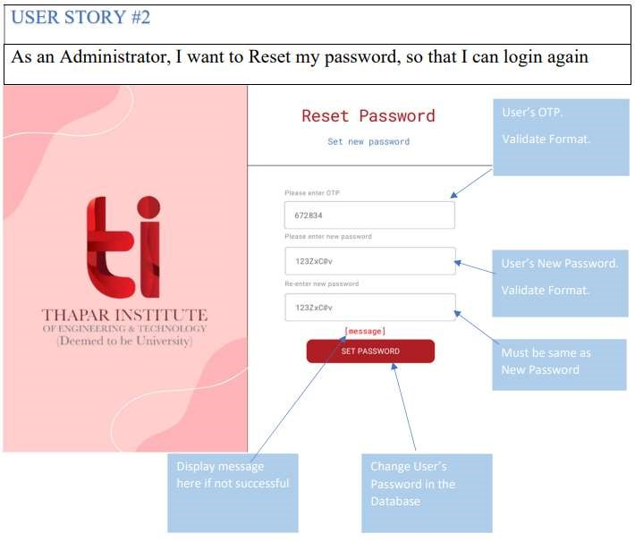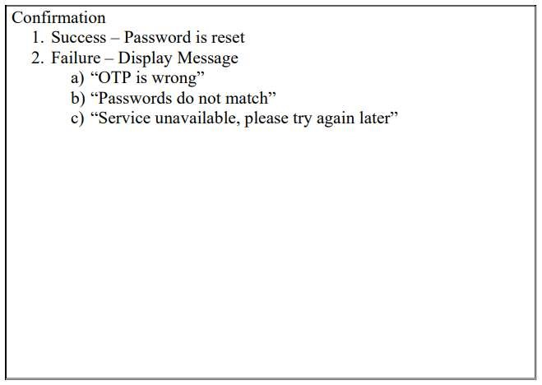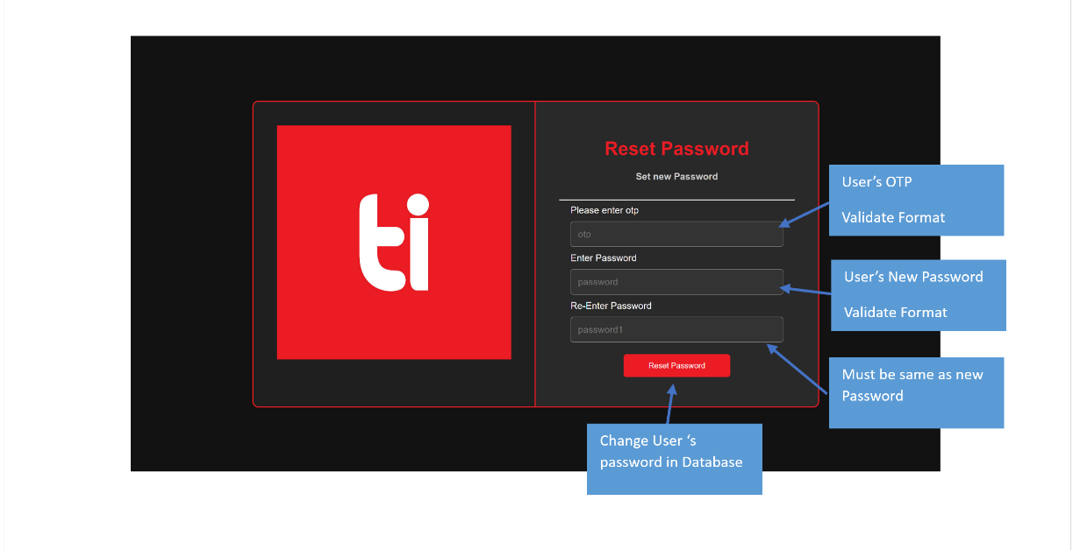

Front side

Back side

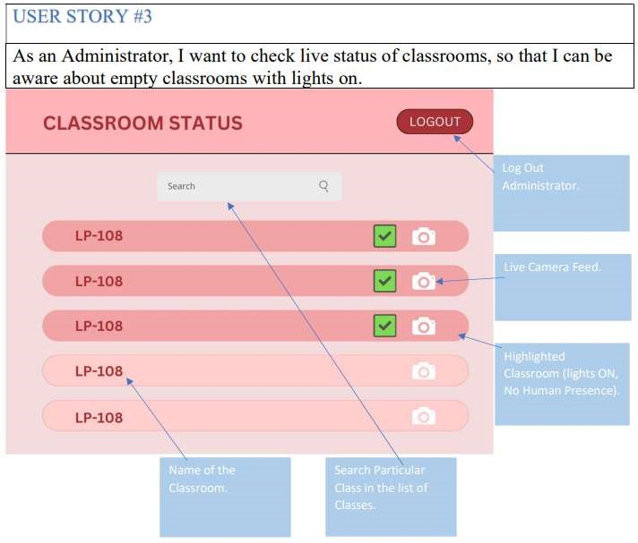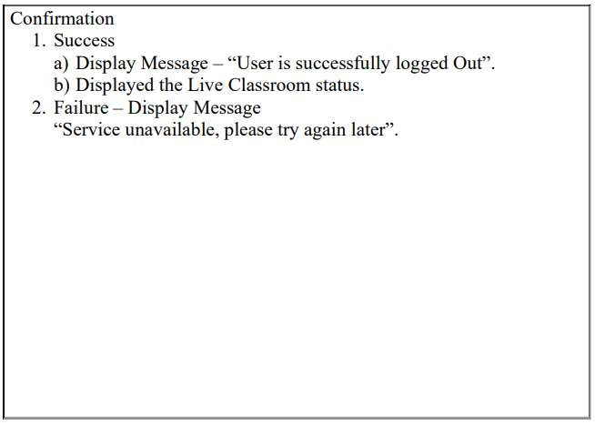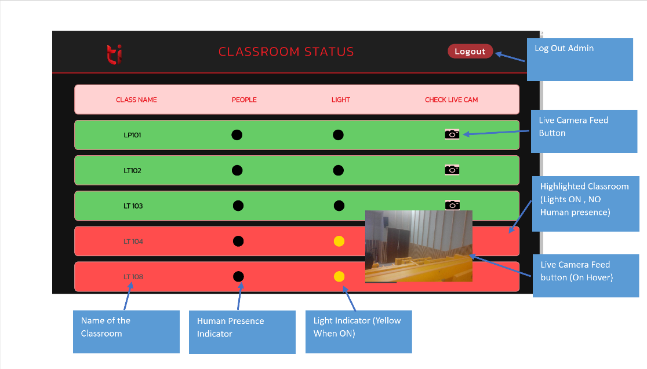

## **3. Design Phase**

## 3.1 Class Diagram

The class diagram is as follows:



## 3.2 Sequence Diagram

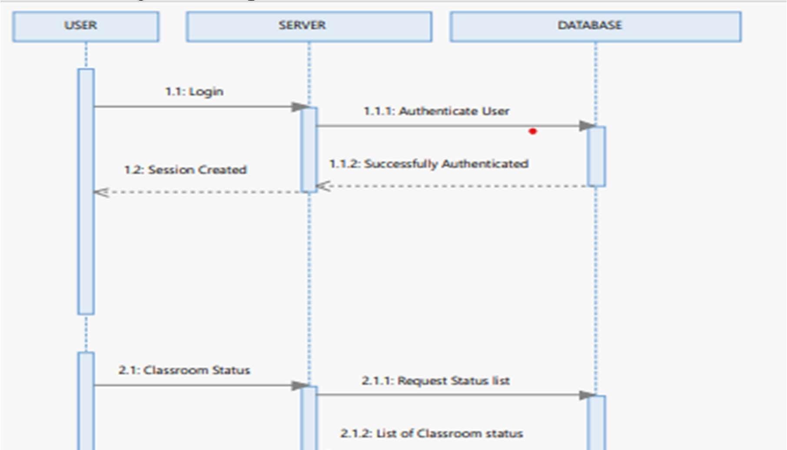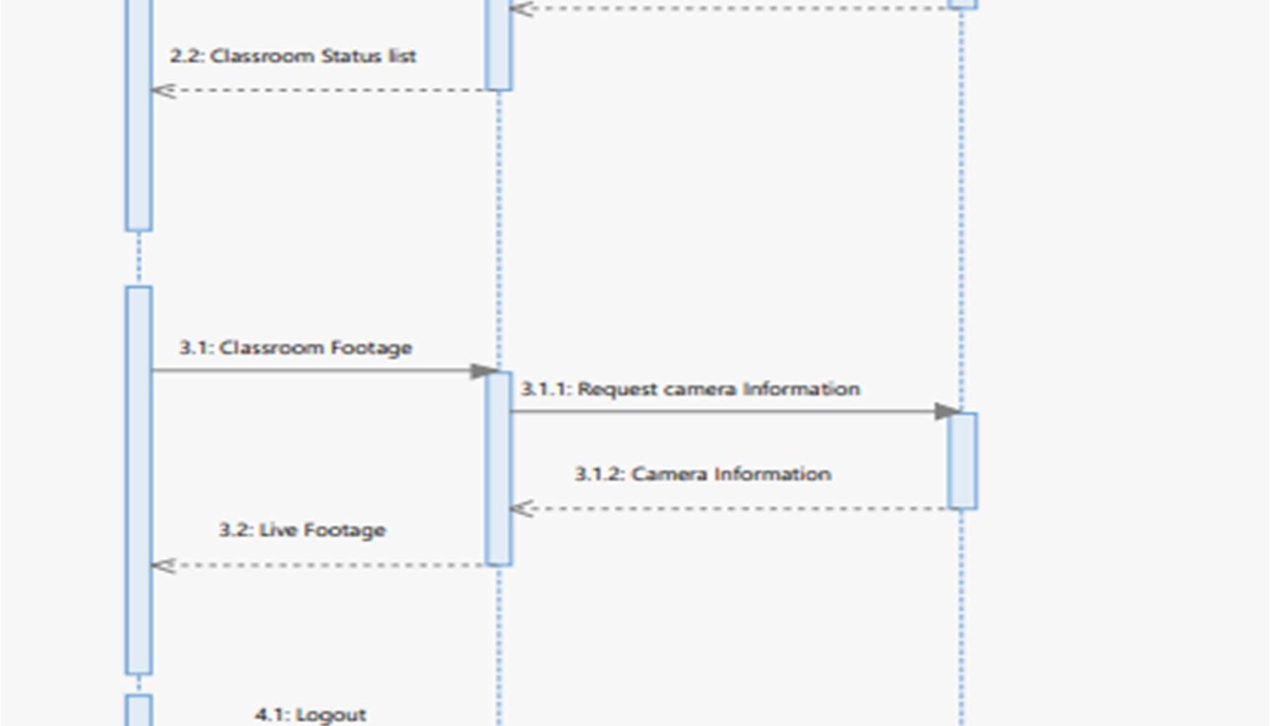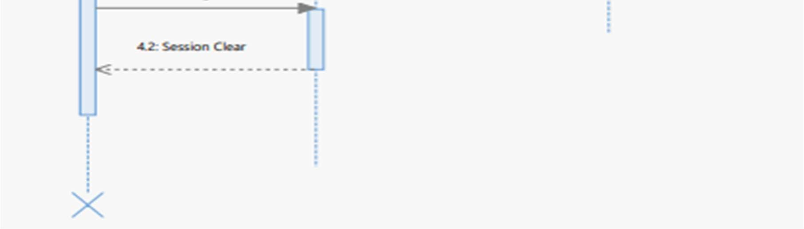

## 3.3 Collaboration Diagram

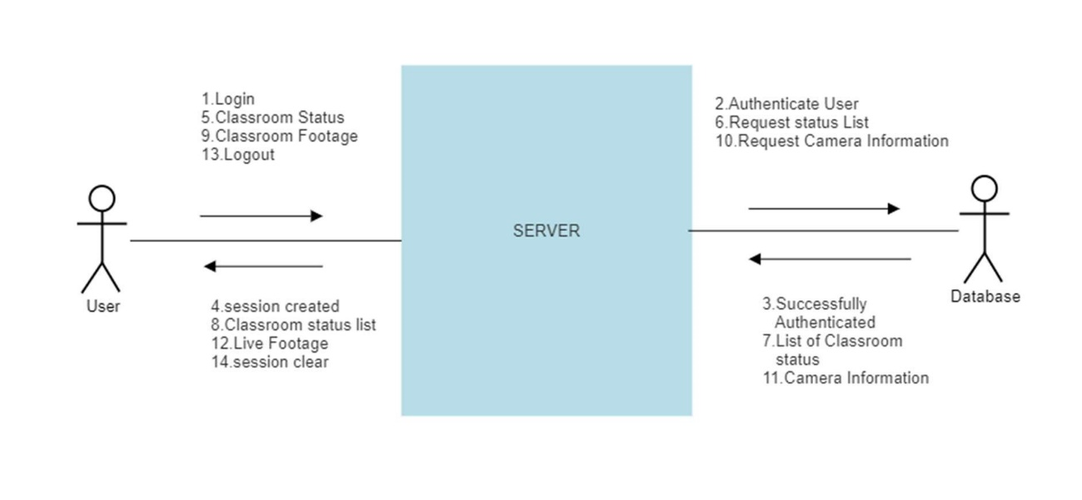

## 3.4 State Chart Diagrams

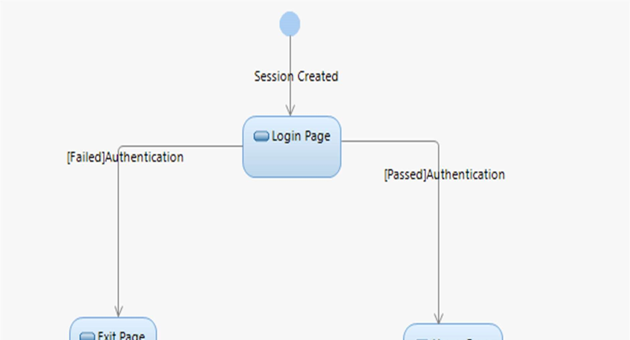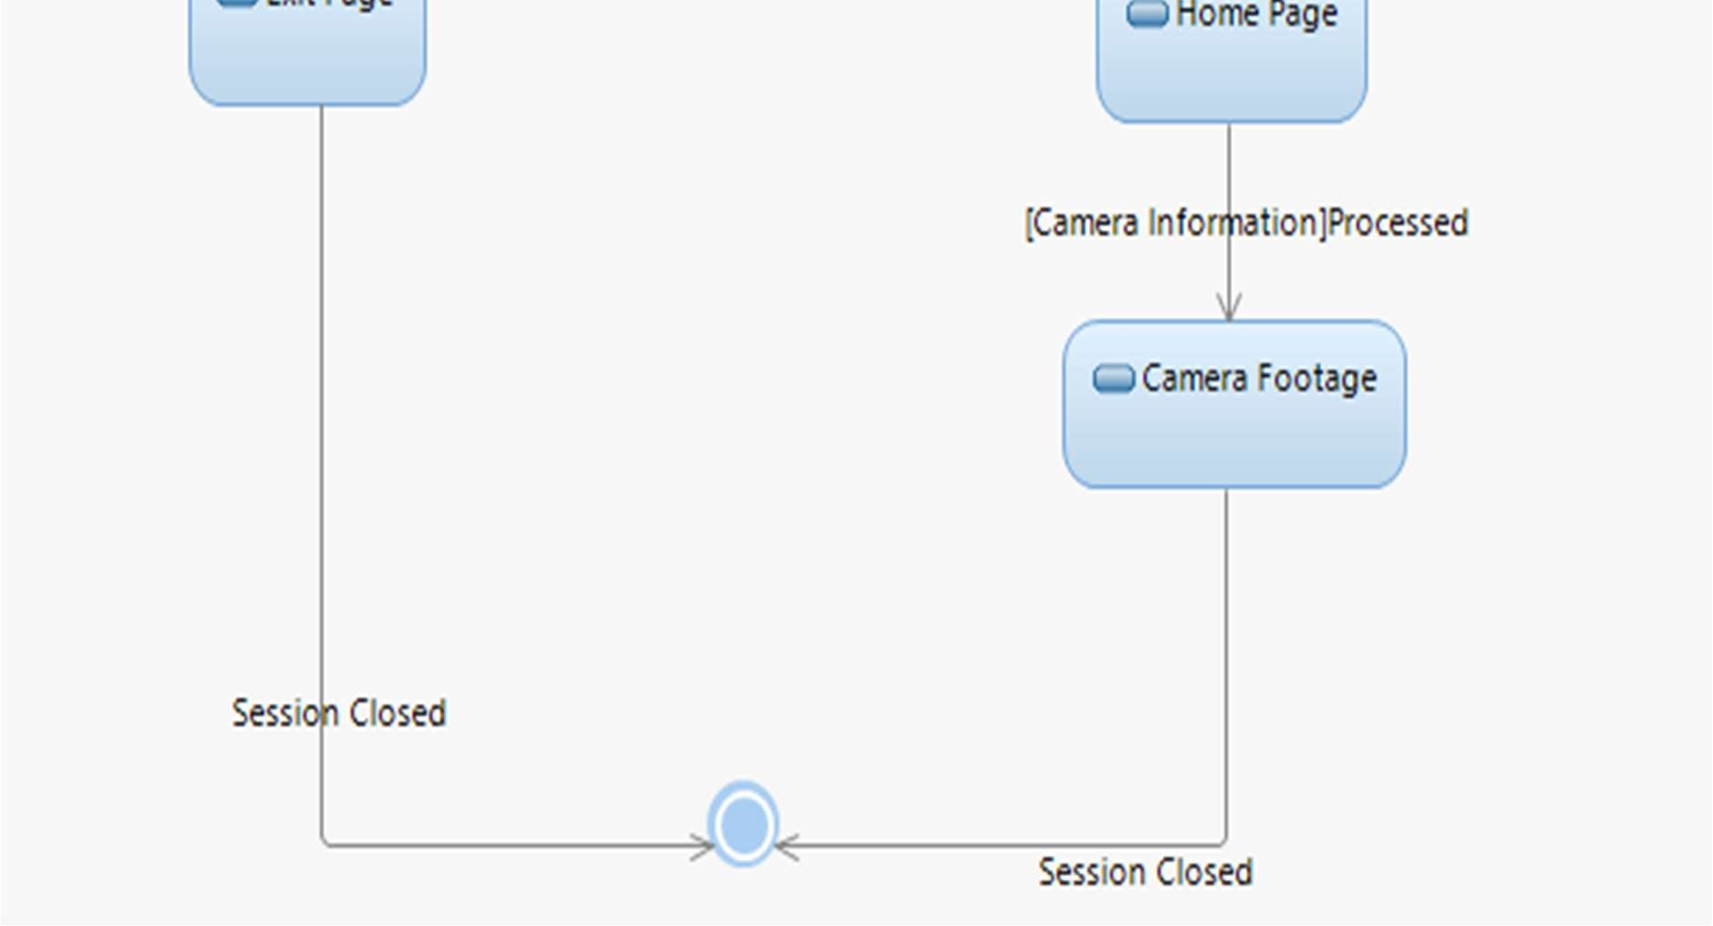

## **4. Implementation**

## 4.1 Component Diagram

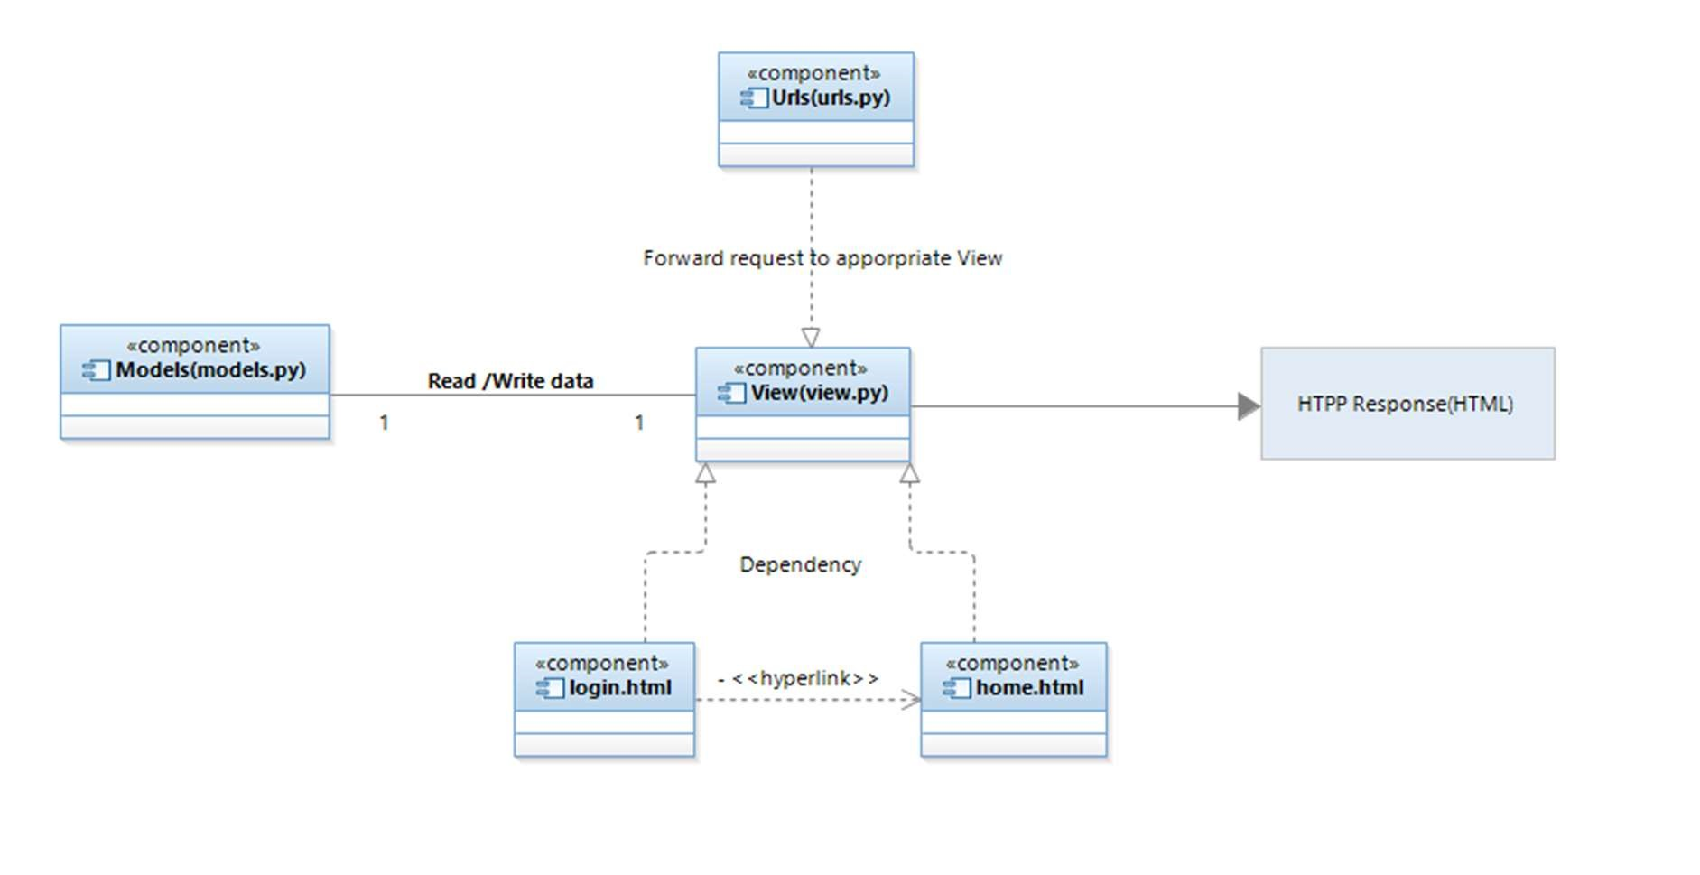

## 4.2 Deployment Diagram

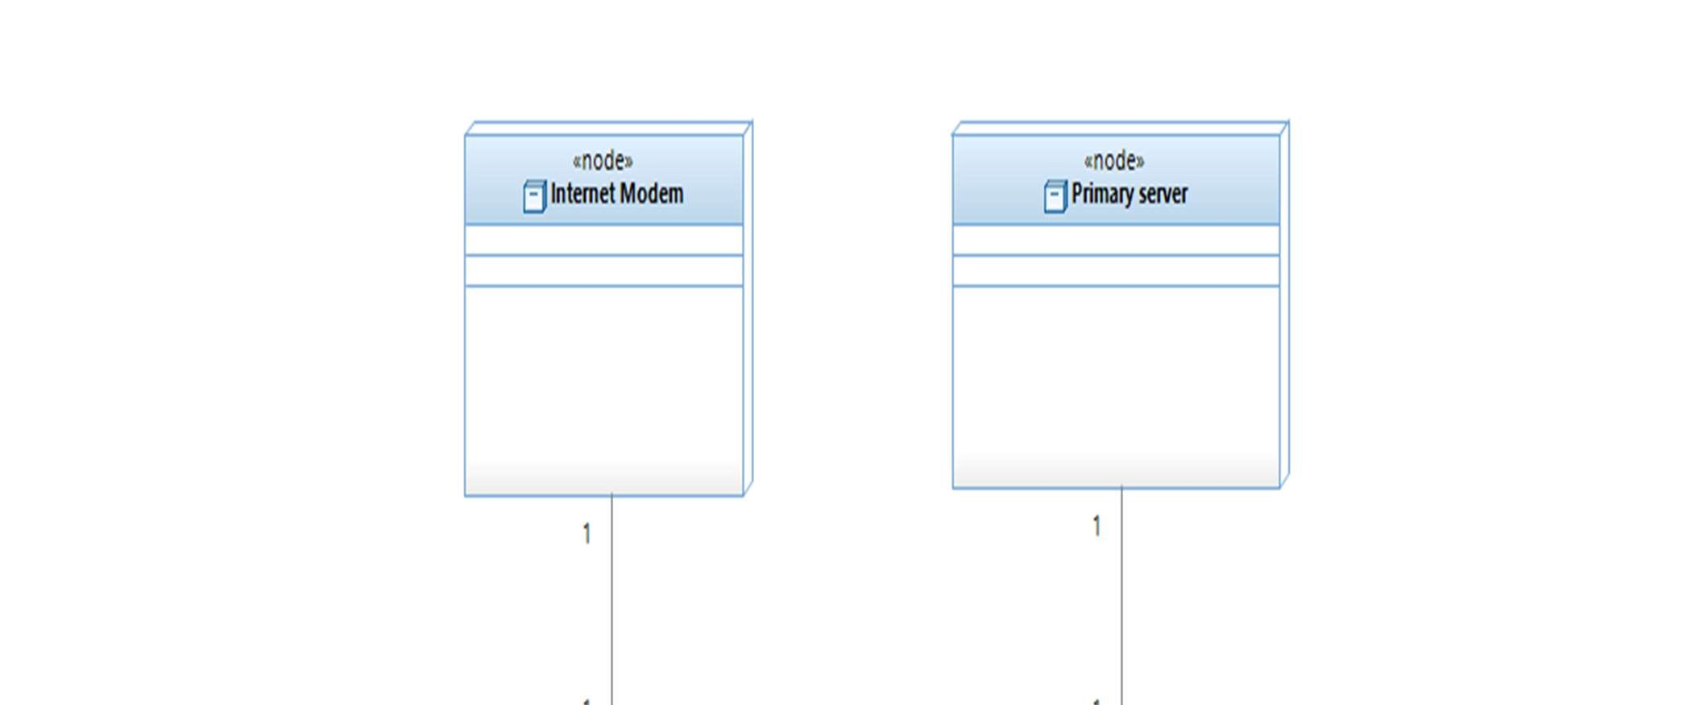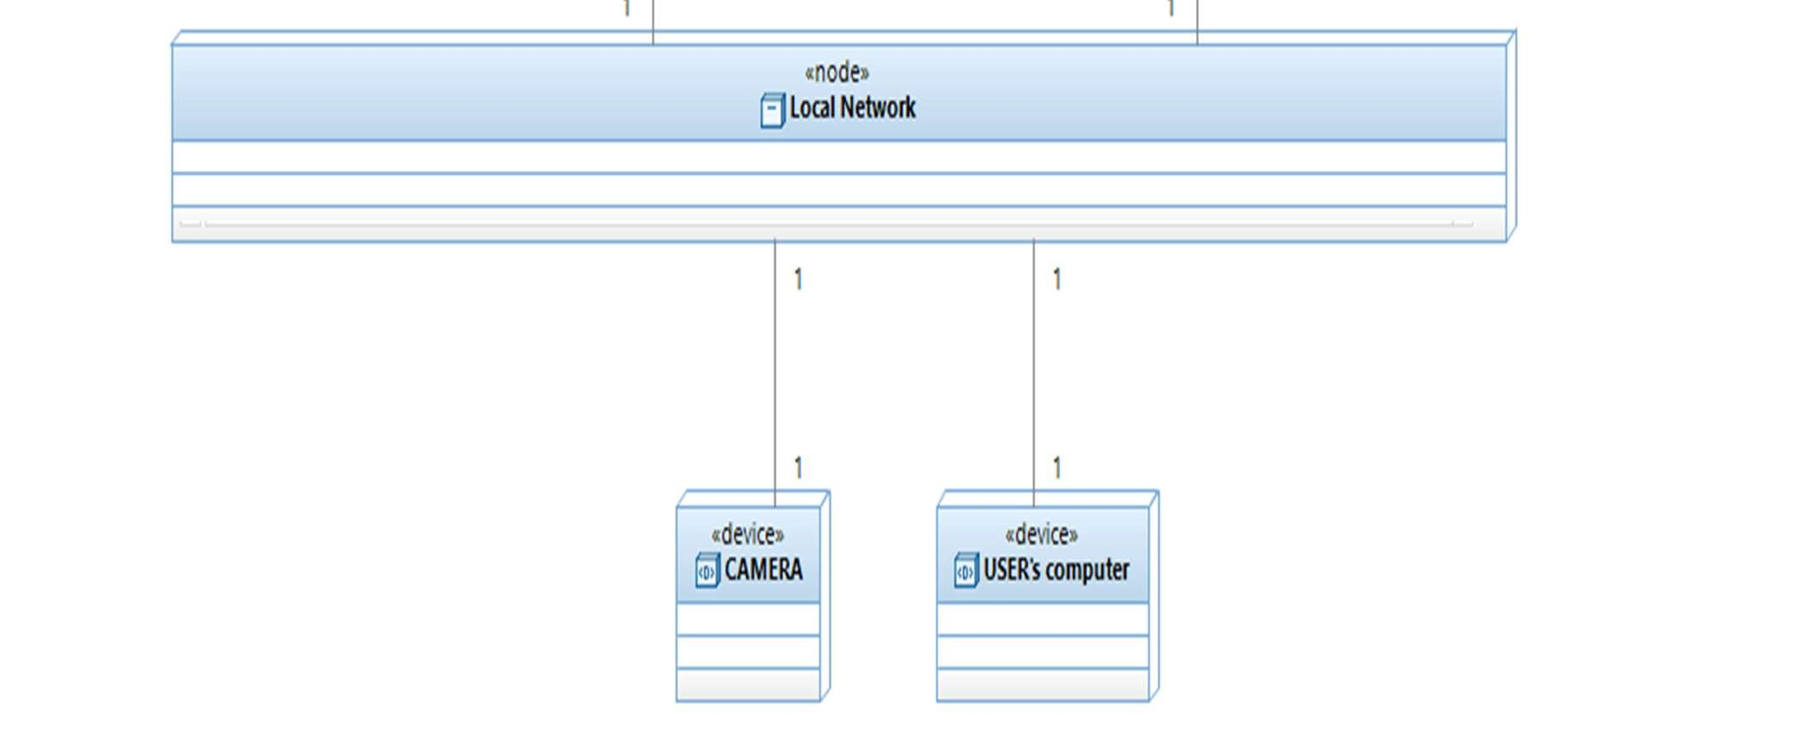

## 4.3 Screenshots

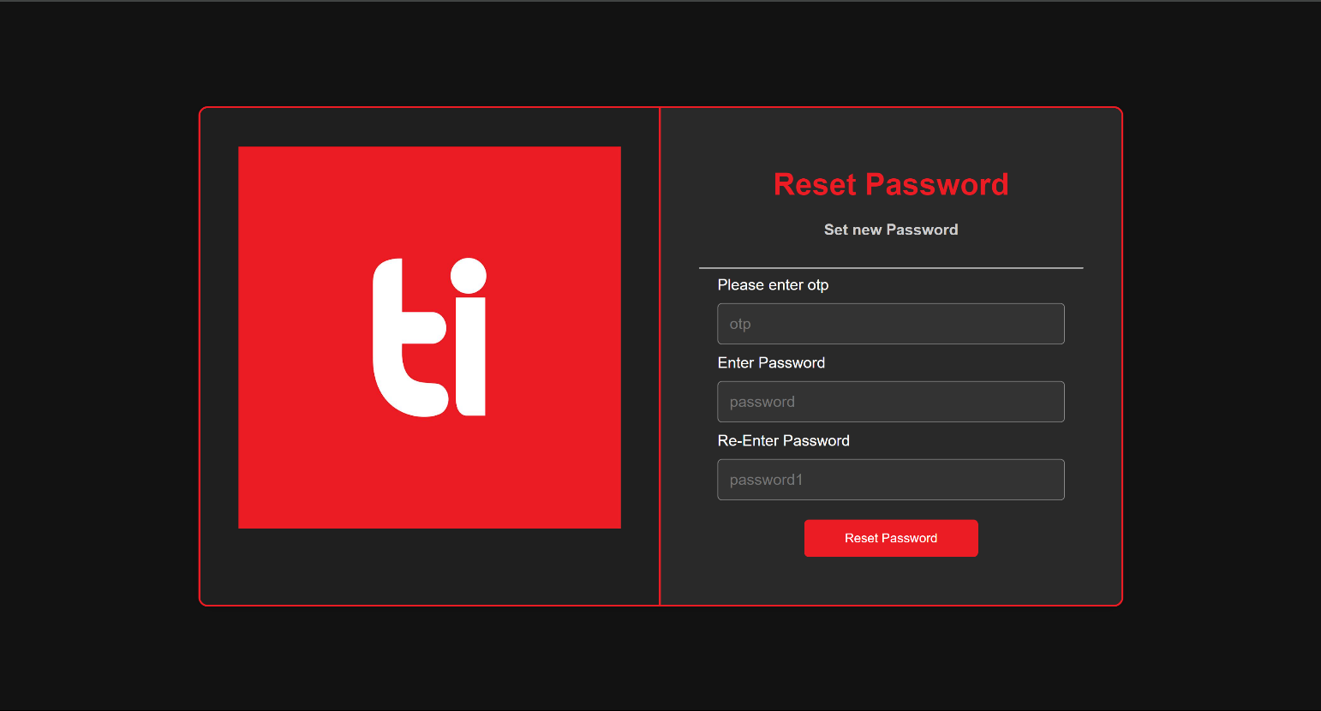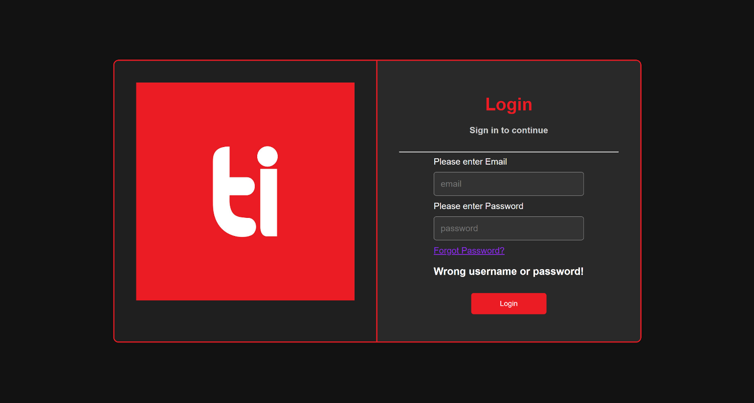

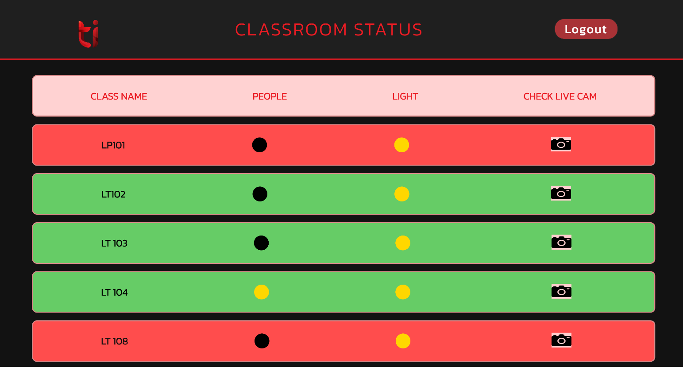

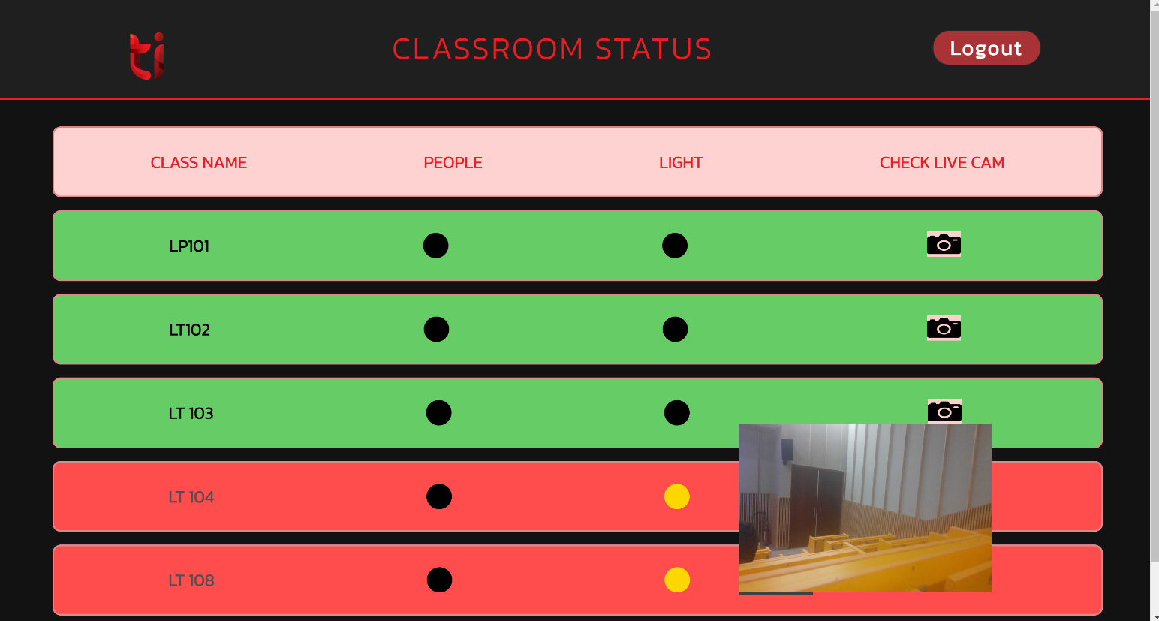

## **5. Testing**

## 5.1 Test Plan

We plan to implement these functionalities for LP classrooms with an audience of 5 people as part of the Pilot Phase. Once the Pilot Phase is successful then we plan to implement it in other classrooms across the institute and eventually we plan to extend our project.

**Tests:**

* 1. Login

The admin will try to login to server

* 1. Reset password

The admin will try to reset password which is forgotten

* 1. Check classroom Status

Once Logged in Admin will try to check classroom Status 4

* 1. View Camera Live Footage

Once Logged in Admin will try to access camera footage of class through website

|  |  |
| --- | --- |
| 5.2 Test Cases | |
| **Test Case ID:** Test1 | **Test Designed by:** Atin Arora |
| **Test Case Name:** Login to Admin Panel | **Test Designed date:** 10/10/23 |
| **System:** Personal Computer | **Test Executed by:** Admin |
| **Description:** The admin needs to login to the admin panel | **Test Execution date:** 11/10/23 |
|  |  |
|  |  |
| **Pre-conditions:**   * User has valid email and password * The current email is [admin@thapar.edu](mailto:admin@thapar.edu) * The current password matches * The website displays the login portal | |
|  | |

|  |  |  |  |  |
| --- | --- | --- | --- | --- |
| **Step** | **Action** | **Expected Result** | **PASS/FAIL** | **Comments** |
| 1 | Enter [admin@thapar.edu](mailto:admin@thapar.edu) as the email | The webpage shows [admin@thapar.edu](mailto:admin@thapar.edu) in the email field |  |  |
| 2 | Enter the associated password | The webpage puts the password in the password field |  |  |
| 3 | Click “LOGIN” button | The webpage shows a message of successful operation and logs you in to the admin panel |  |  |
| 4 | **Check post-condition 1** |  |  |  |
| 5 | Repeat steps 1,2,3 with other email and password | The webpage shows a message of unsuccessful that user does not exist. |  |  |
| 6 | **Check post-condition 2** |  |  |  |

|  |
| --- |
| **Post-conditions:**   1. The admin is logged into the system to access the admin panel 2. The admin is not logged in and redirected to login page |

|  |  |
| --- | --- |
| **Test Case ID:** Test2 | **Test Designed by:** Samarjeet Singh |
| **Test Case Name:** Reset Password | **Test Designed date:** 12/10/23 |
| **System:** Personal Computer | **Test Executed by:** Admin |
| **Description:** Admin needs to change forgotten password | **Test Execution date:** 13/10/23 |
|  |  |
|  |  |
| **Pre-conditions:**   * User has valid email and password * The current email is [admin@thapar.edu](mailto:admin@thapar.edu) * The website displays the forgot password portal | |
|  | |

|  |  |  |  |  |
| --- | --- | --- | --- | --- |
| **Step** | **Action** | **Expected Result** | **PASS/FAIL** | **Comments** |
| 1 | Enter [admin@thapar.edu](mailto:admin@thapar.edu) as the email | The webpage shows [admin@thapar.edu](mailto:admin@thapar.edu) in the email field |  |  |
| 2 | Click on the “SEND” button | The webpage redirects you to the change password portal |  |  |
| 3 | Enter the OTP received on mail | Webpage puts OTP in OTP field |  |  |
| 4 | Enter a new password say “aaa444” | Webpage puts password in password field |  |  |
| 5 | Re-enter “aaa444” in the confirm password field | Webpage puts password in confirm password field |  |  |
| 6 | Click on the “SUBMIT” button | Webpage shows successful operation |  |  |
| 7 | **Check post-condition 1** |  |  |  |
| 8 | Repeat steps 1-6 with wrong OTP | Website shows successful operation  That OTP is incorrect |  |  |
| 9 | **Check post-condition 2** |  |  |  |
| 10 | Repeat steps 1-4 | Webpage puts OTP and password in respective fields. |  |  |
| 11 | Enter wrong password in Re-enter | Webpage puts password in respective fields. |  |  |
| 12 | Click on the “SUBMIT” button | Webpage shows successful operation  That passwords do not match |  |  |
| 13 | **Check post-condition 2** |  |  |  |

|  |
| --- |
| **Post-conditions:**   1. The admin has successfully changed the forgotten password and password is saved in Database 2. The admin is unable to change the password and redirected to change password portal |

|  |  |
| --- | --- |
| **Test Case ID:** Test3 | **Test Designed by:** Khushi |
| **Test Case Name:** Classroom Status | **Test Designed date:** 14/10/23 |
| **System:** Personal Computer | **Test Executed by:** Admin |
| **Description:** The admin needs to check classroom status | **Test Execution date:** 15/10/23 |
|  |  |
|  |  |
| **Pre-conditions:**   * User has valid email and password * The current email is [admin@thapar.edu](mailto:admin@thapar.edu) * The current password matches * The website displays the login portal | |
|  | |

|  |  |  |  |  |
| --- | --- | --- | --- | --- |
| **Step** | **Action** | **Expected Result** | **PASS/FAIL** | **Comments** |
| 1 | Enter [admin@thapar.edu](mailto:admin@thapar.edu) as the email | The webpage shows [admin@thapar.edu](mailto:admin@thapar.edu) in the email field |  |  |
| 2 | Enter the associated password | The webpage puts the password in the password field |  |  |
| 3 | Click “LOGIN” button | The webpage shows a message of successful operation and logs you in to the admin panel |  |  |
| 4 |  | Homepage is shown with list of Classroom Status |  |  |

|  |
| --- |
| **Post-conditions:**   * The admin is logged into the system to access the admin panel |

|  |  |
| --- | --- |
| **Test Case ID:** Test4 | **Test Designed by:** Atin Arora |
| **Test Case Name:** Camera Footage | **Test Designed date:** 16/10/23 |
| **System:** Personal Computer | **Test Executed by:** Admin |
| **Description:** The admin sees the live footage of the classroom | **Test Execution date:** 17/10/23 |
|  |  |
|  |  |
| **Pre-conditions:**   * User has valid email and password * The current email is [admin@thapar.edu](mailto:admin@thapar.edu) * The current password matches * The website displays the login portal | |
|  | |

|  |  |  |  |  |
| --- | --- | --- | --- | --- |
| **Step** | **Action** | **Expected Result** | **PASS/FAIL** | **Comments** |
| 1 | Enter [admin@thapar.edu](mailto:admin@thapar.edu) as the email | The webpage shows [admin@thapar.edu](mailto:admin@thapar.edu) in the email field |  |  |
| 2 | Enter the associated password | The webpage puts the password in the password field |  |  |
| 3 | Click “LOGIN” button | The webpage shows a message of successful operation and logs you in to the admin panel |  |  |
| 4 |  | Homepage is shown with list of Classroom Status |  |  |
| 5 | Click on Camera icon next to Classroom name | User is directed to camera webpage and live footage is shown |  |  |

|  |
| --- |
| **Post-conditions:**   * The admin is logged into the system to access the admin panel |

|  |  |
| --- | --- |
| 5.2 Test Reports | |
| **Test Case ID:** Test1 | **Test Designed by:** Atin Arora |
| **Test Case Name:** Login to Admin Panel | **Test Designed date:** 10/10/23 |
| **System:** Personal Computer | **Test Executed by:** Admin |
| **Description:** The admin needs to login to the admin panel | **Test Execution date:** 11/10/23 |
|  |  |
|  |  |
| **Pre-conditions:**   * User has valid email and password * The current email is [admin@thapar.edu](mailto:admin@thapar.edu) * The current password matches * The website displays the login portal | |
|  | |

|  |  |  |  |  |
| --- | --- | --- | --- | --- |
| **Step** | **Action** | **Expected Result** | **PASS/FAIL** | **Comments** |
| 1 | Enter [admin@thapar.edu](mailto:admin@thapar.edu) as the email | The webpage shows [admin@thapar.edu](mailto:admin@thapar.edu) in the email field | PASS |  |
| 2 | Enter the associated password | The webpage puts the password in the password field | PASS |  |
| 3 | Click “LOGIN” button | The webpage shows a message of successful operation and logs you in to the admin panel | PASS |  |
| 4 | **Check post-condition 1** |  | PASS |  |
| 5 | Repeat steps 1,2,3 with other email and password | The webpage shows a message of unsuccessful that user does not exist. | PASS |  |
| 6 | **Check post-condition 2** |  | PASS |  |

|  |
| --- |
| **Post-conditions:**   1. The admin is logged into the system to access the admin panel 2. The admin is not logged in and redirected to login page |

|  |  |
| --- | --- |
| **Test Case ID:** Test2 | **Test Designed by:** Samarjeet Singh |
| **Test Case Name:** Reset Password | **Test Designed date:** 12/10/23 |
| **System:** Personal Computer | **Test Executed by:** Admin |
| **Description:** Admin needs to change forgotten password | **Test Execution date:** 13/10/23 |
|  |  |
|  |  |
| **Pre-conditions:**   * User has valid email and password * The current email is [admin@thapar.edu](mailto:admin@thapar.edu) * The website displays the forgot password portal | |
|  | |

|  |  |  |  |  |
| --- | --- | --- | --- | --- |
| **Step** | **Action** | **Expected Result** | **PASS/FAIL** | **Comments** |
| 1 | Enter [admin@thapar.edu](mailto:admin@thapar.edu) as the email | The webpage shows [admin@thapar.edu](mailto:admin@thapar.edu) in the email field | PASS |  |
| 2 | Click on the “SEND” button | The webpage redirects you to the change password portal | PASS |  |
| 3 | Enter the OTP received on mail | Webpage puts OTP in OTP field | PASS |  |
| 4 | Enter a new password say “aaa444” | Webpage puts password in password field | PASS |  |
| 5 | Re-enter “aaa444” in the confirm password field | Webpage puts password in confirm password field | PASS |  |
| 6 | Click on the “SUBMIT” button | Webpage shows successful operation | PASS |  |
| 7 | **Check post-condition 1** |  | PASS |  |
| 8 | Repeat steps 1-6 with wrong OTP | Website shows successful operation  That OTP is incorrect | PASS |  |
| 9 | **Check post-condition 2** |  | PASS |  |
| 10 | Repeat steps 1-4 | Webpage puts OTP and password in respective fields. | PASS |  |
| 11 | Enter wrong password in Re-enter | Webpage puts password in respective fields. | PASS |  |
| 12 | Click on the “SUBMIT” button | Webpage shows successful operation  That passwords do not match | PASS |  |
| 13 | **Check post-condition 2** |  | PASS |  |

|  |
| --- |
| **Post-conditions:**   1. The admin has successfully changed the forgotten password and password is saved in Database 2. The admin is unable to change the password and redirected to change password portal |

|  |  |
| --- | --- |
| **Test Case ID:** Test3 | **Test Designed by:** Khushi |
| **Test Case Name:** Classroom Status | **Test Designed date:** 14/10/23 |
| **System:** Personal Computer | **Test Executed by:** Admin |
| **Description:** The admin needs to check classroom status | **Test Execution date:** 15/10/23 |
|  |  |
|  |  |
| **Pre-conditions:**   * User has valid email and password * The current email is [admin@thapar.edu](mailto:admin@thapar.edu) * The current password matches * The website displays the login portal | |
|  | |

|  |  |  |  |  |
| --- | --- | --- | --- | --- |
| **Step** | **Action** | **Expected Result** | **PASS/FAIL** | **Comments** |
| 1 | Enter [admin@thapar.edu](mailto:admin@thapar.edu) as the email | The webpage shows [admin@thapar.edu](mailto:admin@thapar.edu) in the email field | PASS |  |
| 2 | Enter the associated password | The webpage puts the password in the password field | PASS |  |
| 3 | Click “LOGIN” button | The webpage shows a message of successful operation and logs you in to the admin panel | PASS |  |
| 4 |  | Homepage is shown with list of Classroom Status | PASS |  |

|  |
| --- |
| **Post-conditions:**   * The admin is logged into the system to access the admin panel |

|  |  |
| --- | --- |
| **Test Case ID:** Test4 | **Test Designed by:** Atin Arora |
| **Test Case Name:** Camera Footage | **Test Designed date:** 16/10/23 |
| **System:** Personal Computer | **Test Executed by:** Admin |
| **Description:** The admin sees the live footage of the classoom | **Test Execution date:** 17/10/23 |
|  |  |
|  |  |
| **Pre-conditions:**   * User has valid email and password * The current email is [admin@thapar.edu](mailto:admin@thapar.edu) * The current password matches * The website displays the login portal | |
|  | |

|  |  |  |  |  |
| --- | --- | --- | --- | --- |
| **Step** | **Action** | **Expected Result** | **PASS/FAIL** | **Comments** |
| 1 | Enter [admin@thapar.edu](mailto:admin@thapar.edu) as the email | The webpage shows [admin@thapar.edu](mailto:admin@thapar.edu) in the email field | PASS |  |
| 2 | Enter the associated password | The webpage puts the password in the password field | PASS |  |
| 3 | Click “LOGIN” button | The webpage shows a message of successful operation and logs you in to the admin panel | PASS |  |
| 4 |  | Homepage is shown with list of Classroom Status | PASS |  |
| 5 | Click on Camera icon next to Classroom name | User is directed to camera webpage and live footage is shown | PASS |  |

|  |
| --- |
| **Post-conditions:**   * The admin is logged into the system to access the admin panel |